

Capstone Project Document

**FIRST AID**

**Report #2 – Software Requirement Specification**

|  |  |  |
| --- | --- | --- |
| **First Aid** | | |
| **Group Members** | Đàm Huy Hùng | SE03431 |
| Nguyễn Duy Anh | 01525 |
| Mai Trung Kiên | SE02994 |
| Nguyễn Tiến Dũng | SE03272 |
| Nguyễn Phúc An | SE03118 |
| **Supervisor** | Mr. Nguyễn Văn Sang | |
| **Project code** | FAVN | |

**- Hanoi, 09/2016 -**

# **SIGNATURE PAGE**

AUTHOR: Nguyễn Duy Anh 23/09/2016

Team member

REVIEWERS: Đàm Huy Hùng 28/09/2016

Project Manager

APPROVAL: Nguyễn Văn Sang --/--/--16

Supervisor

Record of change

*A - Added M - Modified D – Deleted

|  |  |  |  |  |  |
| --- | --- | --- | --- | --- | --- |
| Effective Date | Changed Item | A,M,D | Change Description | Reason for Change | Rev. Number |
| 01/10/2016 | Create Software Requirements Specifications | A | First version | Create Software Requirements Specifications | 1.0 |
| 02/10/2016 | Modify Business rule, Non-Functional specification | M | First version | Modify Software Requirements Specifications | 1.1 |
| 09/12/2016 | Modify Use case | M | First version | Modify Software Requirements Specifications | 1.2 |
|  |  |  |  |  |  |
|  |  |  |  |  |  |
|  |  |  |  |  |  |

**TABLE CONTENTS**

**1** **SIGNATURE PAGE** 2

**1.** **INTRODUCTION** 5

1.1. Purpose 5

1.2. Definitions and Acronyms 5

1.3. System Purpose 5

**2.** **OVERALL DESCRIPTION** 6

2.1. System overview 6

2.2. Product Features 7

2.2.1. First Aid Application 7

2.2.2. Ambulance Application 7

2.2.3. Dispatcher Application 8

2.2.4. Admin/Expert Application 8

2.3. User Characteristics 8

2.4. User Documentation 9

2.5. Assumption 9

2.6. Entity Relation Model 9

2.6.1. Entity-Relationship Diagram 9

2.6.2. Entity Detail 10

**3.** **FUNCTIONAL SPECIFICATION** 17

3.1. Business Rules 17

3.2. Use Cases 18

3.2.1. First Aid Application 18

3.2.2. Ambulance Application 38

3.2.3. Dispatcher Application 50

3.2.4. Admin/Expert Application 60

**4.** **NON-FUNCTIONAL SPECIFICATION** 75

4.1. Reliability 75

4.2. Performance Requirements 76

4.2.1. Availability 76

4.2.2. Response time 76

4.3. Maintainability 76

4.4. Usability 76

4.5. Security Requirements 76

4.6. Hardware/Software Requirements 76

# **INTRODUCTION**

## **Purpose**

This document is created as the introduction for project First Aid – our Capstone Project at FPT University. In this document, we provide the describing of general requirement and non-functional requirements. These requirements will ensure that the system will correctly and reliably perform its intended functionality. This specification will provide general, as well as specific requirements to be used in the design, testing and validation of the system. It is intended for both stakeholders and the project team of the system.

## **Definitions and Acronyms**

|  |  |  |
| --- | --- | --- |
| **Acronym** | **Definition** | **Note** |
| FAS | First Aid system |  |
| FAA | First Aid application |  |
| AMBA | Ambulance application |  |
| DPA | Dispatcher application |  |
| SRS | Software Requirements Specifications |  |

Table 3-1: Definition and Acronyms

## **System Purpose**

With the aim of providing the best supported health service for Vietnamese people, we want to develop an application that allows users can look up and perform first aid guide and selectively synthesized under step by step format in the easiest way. This application also supports users to search medical facilities around their location. Besides we also want to develop an emergency switchboard system for Hanoi 115 emergency center. It means that this system can connect to aid applications through SOS calling with reducing talking time as well as providing maximum necessary information. In addition, the system also has admin/expert application for managing, automatic functions connected to software on an ambulance in order to shorten the time to contact and distance traveled; functional navigation map and directions to emergency help achieve maximum efficiency.

# **OVERALL DESCRIPTION**

## **System overview**

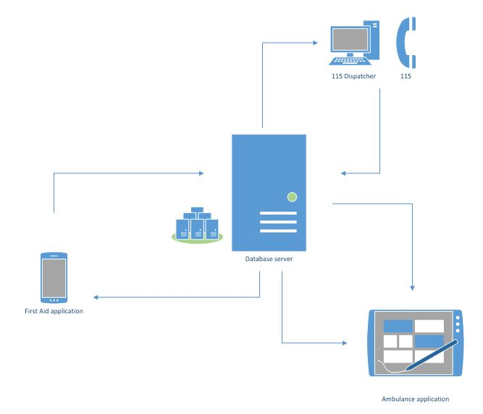

Figure 3-1: System Overview

## **Product Features**

### **First Aid Application**

|  |  |  |  |
| --- | --- | --- | --- |
| UC No. | Group Of Functions | Function | Glossary |
| First Aid Application | | | |
|  | Emergency | View list of injuries |  |
|  | View instruction steps of injury |  |
|  | Search injuries |  |
|  | Call 115 |  |
|  | Read instruction steps |  |
|  | View current location |  |
|  | View list of nearest health facilities |  |
|  | Show direction to health facility |  |
|  | Call to health facility |  |
|  | Learning | View list of learning injuries |  |
|  | View learning instruction steps |  |
|  | View FAQs |  |
|  | More | Send questions |  |
|  | View courses |  |
|  | Share application |  |
|  | Setting | Allow to send information |  |
|  | Information | View application information |  |

Table 3-2: List of use cases

### **Ambulance Application**

|  |  |  |  |  |  |
| --- | --- | --- | --- | --- | --- |
| UC No. | Group Of Functions | | Function | Glossary | |
| Ambulance Application | | | | | |
|  | Common | Login | | |  |
|  | Logout | | |  |
|  | Task | View ambulance team information | | |  |
|  | Change status | | |  |
|  | Notify task | | |  |
|  | View current location | | |  |
|  | Show location of caller | | |  |
|  | Show direction to caller | | |  |
|  | Report picked up caller | | |  |
|  | Report completed task | | |  |
|  | Report problem | | |  |
|  | Information | View application information | | |  |

Table 3-3: List of use cases

### **Dispatcher Application**

|  |  |  |  |  |
| --- | --- | --- | --- | --- |
| UC No. | Group Of Functions | Function | Glossary | |
| Dispatcher Application | | | | |
|  | Common | Login | |  |
|  | Logout | |  |
|  | Dispatch | Create emergency case | |  |
|  | Dispatch ambulance | |  |
|  | View ambulance information | |  |
|  | View caller information | |  |
|  | Show direction from ambulance to caller | |  |
|  | View list of waiting callers | |  |
|  | Notify ambulances status | |  |
|  | Cancel emergency case | |  |

Table 3-4: List of use cases

### **Admin/Expert Application**

|  |  |  |  |  |  |
| --- | --- | --- | --- | --- | --- |
| UC No. | Group Of Functions | | Function | | Glossary |
| Admin/Expert Application | | | | | |
|  | Common | Login | |  | |
|  | Logout | |  | |
|  | Manage user's account | Create account | |  | |
|  | View list of users | |  | |
|  | Search user's account | |  | |
|  | Update user’s account | |  | |
|  | Delete user’s account | |  | |
|  | Manage Q&A | View user’s question | |  | |
|  | View answer | |  | |
|  | Answer question | |  | |
|  | Delete question | |  | |
|  | Manage injury | Add new injury | |  | |
|  | View list of injuries | |  | |
|  | Search injury | |  | |
|  | Update injury | |  | |
|  | Delete injury | |  | |

Table 3-5: List of use cases

## **User Characteristics**

FAS has five objective users:

* **FAA user:** Users uses First Aid application in android mobile.
* **Dispatcher:** Users are offered an account by admin to use Dispatcher website.
* **Ambulance staff:** Users are offered an account by admin to use Ambulance application in tablet.
* **Expert:** Users are offered an account by admin to use First Aid website, they can manage all information about first aid and learning of emergencies, answer the question of FAA users.
* **Admin:** They can manage all information about all user types, answer the question of FAA users.

## **User Documentation**

|  |  |
| --- | --- |
| Name | Description |
| User Guide | Provide detailed explanation about the system, screens and guide users how to use all features of First Aid System. |

Table 3-3: User Documentation

## **Assumption**

* Receive the guidance and good support of teacher.
* No one of member got sick in the software development process.
* In the development process, no device got fail.
* Every report, task meets the deadline.
* Team member do not conflict in the work process.

## **Entity Relation Model**

### **Entity-Relationship Diagram**



**Figure 3-2:** Entity Relationship Diagram

### **Entity Detail**

#### Users table

|  |  |  |  |  |
| --- | --- | --- | --- | --- |
| **No** | **Field Name** | **Type** | **Allow Null** | **Description** |
|  | id | int | No | User’s ID |
|  | username | varchar | No | User’s name |
|  | center_id | varchar |  | User’s password |
|  | role_id | int |  | User’s centerID |
|  | password | int | No | User’s roleID |
|  | name | varchar |  | User’s real name |
|  | phone | varchar |  | User’s phone number |
|  | email | varchar |  | User’s email address |
|  | address | varchar |  | User’ address |
|  | remember_token | varchar |  | User’s |
|  | isDeleted | int |  | User’s delete status |
|  | updated_at | TIMESTAMP |  | User’s updated time |
|  | created_at | TIMESTAMP |  | User’s created time |

Table ‑3: User table

#### Ambulances table

|  |  |  |  |  |
| --- | --- | --- | --- | --- |
| **No** | **Field Name** | **Type** | **Allow Null** | **Description** |
|  | id | int | No | Ambulance’s ID |
|  | user_id | int | No | Ambulance’s userID |
|  | team | varchar |  | Ambulance’s team |
|  | latitude | varchar |  | Ambulance’s latitude |
|  | longitude | varchar |  | Ambulance’s longitude |
|  | status | varchar |  | Ambulance’s status |
|  | caller_taking_id | int | No | Ambulance’s caller taking id |
|  | isDeleted | int |  | Ambulance’s delete status |
|  | updated_at | TIMESTAMP |  | Ambulance’s updated time |
|  | created_at | TIMESTAMP |  | Ambulance’s created time |

Table ‑4: Ambulances table

#### HealthFacilities table

|  |  |  |  |  |
| --- | --- | --- | --- | --- |
| **No** | **Field Name** | **Type** | **Allow Null** | **Description** |
|  | id | int | No | HealthFacility’s ID |
|  | name | varchar |  | HealthFacility’s name |
|  | type | int |  | HealthFacility’s type |
|  | address | int |  | HealthFacility’s address |
|  | vincity | varchar |  | HealthFacility’s vincity |
|  | phone | varchar |  | HealthFacility’s phone number |
|  | latitude | varchar |  | HealthFacility’s latitude |
|  | longitude | varchar |  | HealthFacility’s longitude |
|  | isDeleted | int |  | HealthFacility’s delete status |
|  | updated_at | TIMESTAMP |  | HealthFacility’s updated time |
|  | created_at | TIMESTAMP |  | HealthFacility’s created time |

Table ‑5: HealthFacilities table

#### Faqs table

|  |  |  |  |  |
| --- | --- | --- | --- | --- |
| **No** | **Field Name** | **Type** | **Allow Null** | **Description** |
|  | id | int | No | Faq’s ID |
|  | user_id | int | No | Faq’s userID |
|  | injurie_id | int | No | Faq’s injuryID |
|  | question | varchar |  | Faq’s question |
|  | answer | varchar |  | Faq’s answer |
|  | isDeleted | int |  | Faq’s delete status |
|  | updated_at | TIMESTAMP |  | Faq’s updated time |
|  | created_at | TIMESTAMP |  | Faq’s created time |

Table ‑6: Faqs table

#### Roles table

|  |  |  |  |  |
| --- | --- | --- | --- | --- |
| **No** | **Field Name** | **Type** | **Allow Null** | **Description** |
|  | id | int | No | Role’s ID |
|  | role_name | varchar |  | Role’s name |
|  | isDeleted | int |  | Role’s delete status |
|  | updated_at | TIMESTAMP |  | Role’s updated time |
|  | created_at | TIMESTAMP |  | Role’s created time |

Table ‑7: Roles table

#### Centers table

|  |  |  |  |  |
| --- | --- | --- | --- | --- |
| **No** | **Field Name** | **Type** | **Allow Null** | **Description** |
|  | id | int | No | Center’s ID |
|  | center_name | varchar |  | Center’s name |
|  | phone | varchar |  | Center’s phone number |
|  | email | varchar |  | Center’s email address |
|  | address | varchar |  | Center’s address |
|  | isDeleted | int |  | Center’s delete status |
|  | updated_at | TIMESTAMP |  | Center’s updated time |
|  | created_at | TIMESTAMP |  | Center’s created time |

Table ‑8: Centers table

#### Injuries table

|  |  |  |  |  |  |
| --- | --- | --- | --- | --- | --- |
| **No** | **Field Name** | **Type** | **Allow Null** | **Description** | |
|  | id | int | No | Injury’s ID |
|  | injury_name | varchar |  | Injury’s name |
|  | symptom | varchar |  | Injury’s symptom |
|  | priority | varchar |  | Injury’s priority |
|  | image | varchar |  | Injury’s image |
|  | isDeleted | int |  | Injury’s delete status |
|  | updated_at | TIMESTAMP |  | Injury’s updated time |
|  | created_at | TIMESTAMP |  | Injury’s created time |

Table ‑9: Injuries table

#### Answers table

|  |  |  |  |  |  |
| --- | --- | --- | --- | --- | --- |
| **No** | | **Field Name** | **Type** | **Allow Null** | **Description** |
|  | id | | int | No | Answer’s ID |
|  | user_id | | int | No | Answer’s userID |
|  | question_id | | int | No | Answer’s questionID |
|  | answer | | varchar |  | Answer’s answer |
|  | date | | Date |  | Answer’s date |
|  | isDeleted | | int |  | Answer’s delete status |
|  | updated_at | | TIMESTAMP |  | Answer’s updated time |
|  | created_at | | TIMESTAMP |  | Answer’s created time |

Table ‑: Answers table

#### Questions table

|  |  |  |  |  |
| --- | --- | --- | --- | --- |
| **No** | **Field Name** | **Type** | **Allow Null** | **Description** |
|  | question_id | int | No | Question’s ID |
|  | injury_id | int |  | Question’s injuryID |
|  | asker | varchar |  | Question’s asker name |
|  | asker_email | varchar |  | Question’s asker email address |
|  | title | varchar |  | Question’s title |
|  | content | varchar |  | Question’s content |
|  | count_answer | int |  | Question’s countAnswer |
|  | isDeleted | int |  | Question’s delete status |
|  | updated_at | TIMESTAMP |  | Question’s updated time |
|  | created_at | TIMESTAMP |  | Question’s created time |

Table ‑: Questions table

#### 2.6.2.10. Update table

|  |  |  |  |  |
| --- | --- | --- | --- | --- |
| **No** | **Field Name** | **Type** | **Allow Null** | **Description** |
|  | id | int |  | Update’s ID |
|  | table_name | varchar |  | Update’s table name |
|  | updated_at | TIMESTAMP |  | Update’s updated time |
|  | created_at | TIMESTAMP |  | Update’s created time |

Table ‑: Update table

#### 2.6.2.11. Notifications table

|  |  |  |  |  |
| --- | --- | --- | --- | --- |
| **No** | **Field Name** | **Type** | **Allow Null** | **Description** |
|  | id | int | No | Notification’s ID |
|  | noti_type_id | int | No | Notification’s notification type ID |
|  | type_id | int |  | Notification’s typeID |
|  | updated_at | TIMESTAMP |  | Notification’s updated time |
|  | created_at | TIMESTAMP |  | Notification’s created time |

Table ‑: Notifications table

#### 2.6.2.12. Callers table

|  |  |  |  |  |
| --- | --- | --- | --- | --- |
| **No** | **Field Name** | **Type** | **Allow Null** | **Description** |
|  | id | int | No | Caller’s ID |
|  | injury_id | int |  | Caller’s injuryID |
|  | phone | varchar |  | Caller’s phone number |
|  | symptom | varchar |  | Caller’s symptom |
|  | latitude | varchar |  | Caller’s latitude |
|  | longitude | varchar |  | Caller’s longitude |
|  | status | varchar |  | Caller’s status |
|  | dispatcher_user_id | int |  | Caller’s dispatcher user ID |
|  | ambulance_user_id | int |  | Caller’s ambulance user ID |
|  | isDeleted | int |  | Caller’s delete status |
|  | updated_at | TIMESTAMP |  | Caller’s updated time |
|  | created_at | TIMESTAMP |  | Caller’s created time |

Table ‑: Caller table

#### 2.6.2.13. Instructions table

|  |  |  |  |  |
| --- | --- | --- | --- | --- |
| **No** | **Field Name** | **Type** | **Allow Null** | **Description** |
|  | id | int | No | Instruction’s ID |
|  | injury_id | int | No | Instruction’s injuryID |
|  | step | int | No | Instruction’s step |
|  | content | varchar |  | Instruction’s content |
|  | isMakeCall | int |  | Instruction’s make call status |
|  | image | varchar |  | Instruction’s image |
|  | audio | varchar |  | Instruction’s audio |
|  | isDeleted | int |  | Instruction’s delete status |
|  | updated_at | TIMESTAMP |  | Instruction’s updated time |
|  | created_at | TIMESTAMP |  | Instruction’s created time |

Table ‑: Instruction table

#### 2.6.2.14. LearningInstructions table

|  |  |  |  |  |
| --- | --- | --- | --- | --- |
| **No** | **Field Name** | **Type** | **Allow Null** | **Description** |
|  | id | int | No | LearningInstruction’s ID |
|  | injury_id | int | No | LearningInstruction’s injury ID |
|  | step | int | No | LearningInstruction’s step |
|  | content | varch |  | LearningInstruction’s content |
|  | explain | varchar |  | LearningInstruction’s explain |
|  | image | varchar |  | LearningInstruction’s image |
|  | audio | varchar |  | LearningInstruction’s audio |
|  | isDeleted | int |  | LearningInstruction’s delete status |
|  | updated_at | TIMESTAMP |  | LearningInstruction’s updated time |
|  | created_at | TIMESTAMP |  | LearningInstruction’s created time |

Table ‑16: LearningInstruction table

#### 2.6.2.15. NotificationTypes table

|  |  |  |  |  |
| --- | --- | --- | --- | --- |
| **No** | **Field Name** | **Type** | **Allow Null** | **Description** |
| 1 | id | int | No | NotificationType’s ID |
| 2 | noti_type_name | varchar |  | NotificationType’s name |
| 3 | updated_at | TIMESTAMP |  | NotificationType’s updated time |
| 4 | created_at | TIMESTAMP |  | NotificationType’s created time |

Table ‑17: NotificationType table

# **FUNCTIONAL SPECIFICATION**

## **Business Rules**

|  |  |
| --- | --- |
| **No** | **Description** |
|  | Content is limited to 500 characters |
|  | Text field cannot be empty |
|  | Email must content characters ‘@’ and ‘.’ |
|  | Displayed date is yyyy/mm/dd format |

Table 2-13: Business rules

## **Use Cases**

### **First Aid Application**

#### Emergencies Module

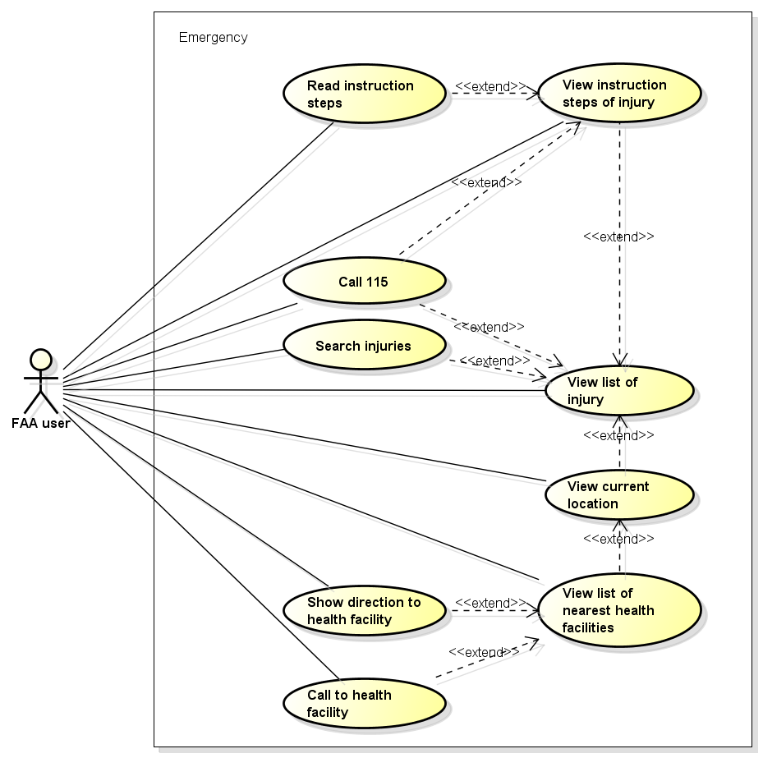

Figure -4: Emergencies use case

##### UC001 - View list of injury

|  |  |  |  |  |
| --- | --- | --- | --- | --- |
| **Use Case ID** | | UC001 | **Version** | 1.1 |
| **Use Case Name** | | View list of injury | | |
| **Created by:** | | AnhND | **Date Created:** | 24/09/2016 |
| **Primary Actor** | | FAA user | **Secondary Actor** |  |
| **Description:** | | This function allows user to view all injuries need to first aid in First Aid application. | | |
| **Preconditions:** | | Install First Aid application | | |
| **Trigger:** | | User launches application | | |
| **Post conditions:** | | All existing injuries will be displayed in the Emergency screen. | | |
| **Normal Flow** | | | | |
| **Step** | **Actor** | **Action** | | |
| 1 | FAA user | Launch application | | |
| 2 | FAA | Show all existing injuries | | |
| **Alternative Flows: N/A** | | | | |
| **Exceptions: N/A** | | | | |
| **Priority** | | High | | |
| **Frequency of Use:** | | High | | |
| **Business Rules:** | |  | | |
| **Other Information:** | | N/A | | |

Table 2- 4: View list of injury

##### UC002 - View instruction steps of injury

|  |  |  |  |  |
| --- | --- | --- | --- | --- |
| **Use Case ID** | | UC002 | **Version** | 1.1 |
| **Use Case Name** | | View instruction steps of injury | | |
| **Created by:** | | AnhND | **Date Created:** | 24/09/2016 |
| **Primary Actor** | | FAA user | **Secondary Actor** |  |
| **Description:** | | This function allows user to view first aid instruction step of an injuries. | | |
| **Preconditions:** | | 1. Install First Aid application 2. User launches application | | |
| **Trigger:** | | User taps on an injury in the list of injuries that displayed in the Emergency screen. | | |
| **Post conditions:** | | All first aid instruction step about this injury will be displayed in the Emergency screen. | | |
| **Normal Flow** | | | | |
| **Step** | **Actor** | **Action** | | |
| 1 | FAA user | Launch application | | |
| 2 | FAA user | Tap on an injury in the list | | |
| 3 | FAA | Show all first aid instruction step | | |
| **Alternative Flows:** | | | | |
| **AT1** | At step 3 in the main flows, if user taps on Back buttons. | | | |
| **Step** | **Actor** | **Action** | | |
| 2.1 | FAA | Redirects user to Emergency screen | | |
| **Exceptions: N/A** | | | | |
| **Priority** | | High | | |
| **Frequency of Use:** | | High | | |
| **Business Rules:** | |  | | |
| **Other Information:** | | N/A | | |

Table 2- 4: View instruction steps of injury

##### UC003 - Search injuries

|  |  |  |  |  |
| --- | --- | --- | --- | --- |
| **Use Case ID** | | UC003 | **Version** | 1.1 |
| **Use Case Name** | | Search injuries | | |
| **Created by:** | | AnhND | **Date Created:** | 24/09/2016 |
| **Primary Actor** | | FAA user | **Secondary Actor** |  |
| **Description:** | | This function allows user to search an injury exits on FAA by text | | |
| **Preconditions:** | | 1. Install First Aid application 2. User launches application | | |
| **Trigger:** | | User taps on Search button, enters search phrase and taps Search | | |
| **Post conditions:** | | All results that matched with the keyword user enters will be displayed in the Emergency screen. | | |
| **Normal Flow** | | | | |
| **Step** | **Actor** | **Action** | | |
| 1 | FAA user | Tap on Search button | | |
| 2 | FAA user | Enter search phrase to text box | | |
| 3 | FAA user | Tap Search | | |
| 4 | FAA | List all results that matched with the keyword user entered | | |
| **Alternative Flows:** | | | | |
| **AT1** | At step 2 in the main flows, if user taps on an injury in the list under the text box. | | | |
| **Step** | **Actor** | **Action** | | |
| 2.1 | FAA | Redirects user to first aid instruction step of chosen injury. | | |
| **AT2** | At step 2 in the main flows, if user taps on Back button. | | | |
| **Step** | **Actor** | **Action** | | |
| 2.1 | FAA | Redirects user to Emergency screen | | |
| **AT3** | At step 3 in the main flows, if user taps on [x] button | | | |
| **Step** | **Actor** | **Action** | | |
| 3.1 | FAA | Redirects user to text box to enters search phrase | | |
| **Exceptions: N/A** | | | | |
| **Priority** | | High | | |
| **Frequency of Use:** | | High | | |
| **Business Rules:** | |  | | |
| **Other Information:** | | N/A | | |

Table 2- 15: Search injuries

##### UC004 - Call 115

|  |  |  |  |  |
| --- | --- | --- | --- | --- |
| **Use Case ID** | | UC004 | **Version** | 1.1 |
| **Use Case Name** | | Call 115 | | |
| **Created by:** | | AnhND | **Date Created:** | 24/09/2016 |
| **Primary Actor** | | FAA user | **Secondary Actor** |  |
| **Description:** | | This function allows user to make emergency calls to the 115 center and send user’s information if user allows. | | |
| **Preconditions:** | | 1. Install First Aid application 2. User launches application | | |
| **Trigger:** | | User tap on call button in the Emergency screen or user tap on an injury to view instruction steps of injury and tap on call button that below a step. | | |
| **Post conditions:** | | Call to 115 center. If user allows to send information that set in Setting, FFA will send user’s information (include location and phone number) to Dispatcher application. | | |
| **Normal Flow** | | | | |
| **Step** | **Actor** | **Action** | | |
| 1 | FAA user | Tap on Call button/ User taps on an injury in the list of injuries then tap on Call 115 button. | | |
| 2 | FAA | Call to 115 and send user’s information if any. | | |
| **Alternative Flows: N/A** | | | | |
| **Exceptions: N/A** | | | | |
| **Priority** | | High | | |
| **Frequency of Use:** | | High | | |
| **Business Rules:** | |  | | |
| **Other Information:** | | N/A | | |

Table 2- 15: Call 115

##### UC005 - Read instruction steps

|  |  |  |  |  |
| --- | --- | --- | --- | --- |
| **Use Case ID** | | UC005 | **Version** | 1.1 |
| **Use Case Name** | | Read instruction steps | | |
| **Created by:** | | AnhND | **Date Created:** | 24/09/2016 |
| **Primary Actor** | | FAA user | **Secondary Actor** |  |
| **Description:** | | This function allows user listening FAA reads an instruction step. | | |
| **Preconditions:** | | 1. Install First Aid application 2. User launches application 3. User chooses an injury that want to see | | |
| **Trigger:** | | User tap on any instruction step. | | |
| **Post conditions:** | | Instruction step is read | | |
| **Normal Flow** | | | | |
| **Step** | **Actor** | **Action** | | |
| 1 | FAA user | Tap on an instruction step | | |
| 2 | FAA | Read instruction step | | |
| **Alternative Flows:** | | | | |
| **AT1** | At step 2 in main flow, if user taps again on this instruction step. | | | |
| **Step** | **Actor** | **Action** | | |
| 2.1 | FAA | Pause reading instruction step | | |
| 2.2 | FAA user | Tap again on this instruction step | | |
| 2.3 | FAA | Continue to read this instruction step | | |
| 2.4 | FAA user | Tap on other instruction step | | |
| 2.5 | FAA | Read new instruction step | | |
| **Exceptions: N/A** | | | | |
| **Priority** | | High | | |
| **Frequency of Use:** | | High | | |
| **Business Rules:** | |  | | |
| **Other Information:** | | N/A | | |

Table 2- 15: Read instruction steps

##### UC006 - View current location

|  |  |  |  |  |
| --- | --- | --- | --- | --- |
| **Use Case ID** | | UC006 | **Version** | 1.1 |
| **Use Case Name** | | View current location | | |
| **Created by:** | | AnhND | **Date Created:** | 24/09/2016 |
| **Primary Actor** | | FAA user | **Secondary Actor** |  |
| **Description:** | | This function allows user to locate their current location correctly. | | |
| **Preconditions:** | | 1. Install First Aid application 2. User launches application | | |
| **Trigger:** | | User taps on Direct button | | |
| **Post conditions:** | | The location of user is displayed in the Map | | |
| **Normal Flow** | | | | |
| **Step** | **Actor** | **Action** | | |
| 1 | FAA user | Tap on Direct button | | |
| 2 | FAA | Displayed the location of user in the Map, include: - Latitude and Longitude - Vicinity (if has internet) | | |
| **Alternative Flows:** | | | | |
| **AT1** | At step 2 in main flow, if user scrolls in the Map | | | |
| **Step** | **Actor** | **Action** | | |
| 2.1 | FAA | The Map is moved | | |
| 2.2 | FAA user | Tap on Locate button | | |
| 2.3 | FAA | Return to the current location of user | | |
| **AT2** | At step 2 in main flow, if user taps on Back button | | | |
| **Step** | **Actor** | **Action** | | |
| 2.1 | FAA | Redirects user to Emergency screen | | |
| **Exceptions: N/A** | | | | |
| **Priority** | | High | | |
| **Frequency of Use:** | | High | | |
| **Business Rules:** | |  | | |
| **Other Information:** | | N/A | | |

Table 2- 15: View current location

##### UC007 - View list of nearest health facilities

|  |  |  |  |  |
| --- | --- | --- | --- | --- |
| **Use Case ID** | | UC007 | **Version** | 1.1 |
| **Use Case Name** | | View list of nearest health facilities | | |
| **Created by:** | | AnhND | **Date Created:** | 24/09/2016 |
| **Primary Actor** | | FAA user | **Secondary Actor** |  |
| **Description:** | | This function allows user to view list of nearest health facilities from their location. | | |
| **Preconditions:** | | 1. Install First Aid application 2. User launches application 3. User taps on Direct button | | |
| **Trigger:** | | User taps on “Cơ sở y tế gần đây” button | | |
| **Post conditions:** | | List of nearest health facilities are displayed | | |
| **Normal Flow** | | | | |
| **Step** | **Actor** | **Action** | | |
| 1 | FAA user | Tap on “Cơ sở y tế gần đây” button | | |
| 2 | FAA | Show table list of nearest health facilities within a radius 20km, classify in 3 tabs: - “Tất Cả” - “Bệnh Viện” - “Trạm Y Tế” With “Tất Cả” is default tab Content of each tab: - Name - Address or Vicinity - Distance: from user to this health facility, sort from near to far (if has internet) - Button Call: if has phone number of health facility | | |
| **Alternative Flows:** | | | | |
| **AT1** | At step 2 in main flow, user taps on [x] button | | | |
| **Step** | **Actor** | **Action** | | |
| 2.1 | FAA | Redirect user to the Map | | |
| **Exceptions: N/A** | | | | |
| **Priority** | | High | | |
| **Frequency of Use:** | | High | | |
| **Business Rules:** | |  | | |
| **Other Information:** | | N/A | | |

Table 2- 15: View list of nearest health facilities

##### UC008 - Show direction to health facility

|  |  |  |  |  |
| --- | --- | --- | --- | --- |
| **Use Case ID** | | UC008 | **Version** | 1.1 |
| **Use Case Name** | | Show direction to health facility | | |
| **Created by:** | | AnhND | **Date Created:** | 24/09/2016 |
| **Primary Actor** | | FAA user | **Secondary Actor** |  |
| **Description:** | | This function allows user to view the shortest direction from user’s location to a health facility address | | |
| **Preconditions:** | | 1. Install First Aid application 2. User launches application 3. Mobile has Network 4. User taps on “Cơ sở y tế gần đây” 5. User taps on any health facility | | |
| **Trigger:** | | User taps on any Direct button | | |
| **Post conditions:** | | The shortest direction from user’s location to a health facility is displayed | | |
| **Normal Flow** | | | | |
| **Step** | **Actor** | **Action** | | |
| 1 | FAA user | Tap on Direct button | | |
| 2 | FAA | Show the shortest direction from user’s location to a health facility | | |
| **Alternative Flows:** | | | | |
| **AT1** | At step 2 in main flow, if user taps on [x] button | | | |
| **Step** | **Actor** | **Action** | | |
| 2.1 | FAA | Clear the direction | | |
| **AT2** | At step 2 in main flow, if user scrolls in the Map | | | |
| **Step** | **Actor** | **Action** | | |
| 2.1 | FAA | The Map is moved | | |
| 2.2 | FAA user | Tap on health facility name | | |
| 2.3 | FAA | Zoom in health facility location | | |
| **Exceptions: N/A** | | | | |
| **Priority** | | High | | |
| **Frequency of Use:** | | High | | |
| **Business Rules:** | |  | | |
| **Other Information:** | | N/A | | |

Table 2- 15: Show direction to health facility

##### UC009 - Call to health facility

|  |  |  |  |  |
| --- | --- | --- | --- | --- |
| **Use Case ID** | | UC009 | **Version** | 1.1 |
| **Use Case Name** | | Call to health facility | | |
| **Created by:** | | AnhND | **Date Created:** | 24/09/2016 |
| **Primary Actor** | | FAA user | **Secondary Actor** |  |
| **Description:** | | This function allows user to call to the health facility | | |
| **Preconditions:** | | 1. Install First Aid application 2. User launches application 3. User taps on “Cơ sở y tế gần đây” 4. Health facility in the list has phone number | | |
| **Trigger:** | | User taps on Call button | | |
| **Post conditions:** | | Call to health facility | | |
| **Normal Flow** | | | | |
| **Step** | **Actor** | **Action** | | |
| 1 | FAA user | Taps on Call button | | |
| 2 | FAA | Call to health facility | | |
| **Alternative Flows: N/A** | | | | |
| **Exceptions: N/A** | | | | |
| **Priority** | | High | | |
| **Frequency of Use:** | | High | | |
| **Business Rules:** | |  | | |
| **Other Information:** | | N/A | | |

Table 2- 15: Call to health facility

#### Learning Module

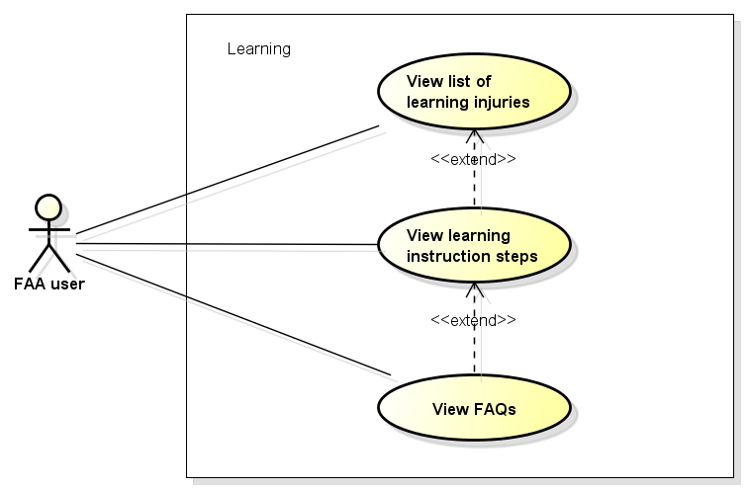

Figure -5: Learning use case

##### UC0010 - View list of learning injuries

|  |  |  |  |  |
| --- | --- | --- | --- | --- |
| **Use Case ID** | | UC0010 | **Version** | 1.1 |
| **Use Case Name** | | View list of learning injuries | | |
| **Created by:** | | AnhND | **Date Created:** | 24/09/2016 |
| **Primary Actor** | | FAA user | **Secondary Actor** |  |
| **Description:** | | This function allows user to view all learning about injuries | | |
| **Preconditions:** | | 1. Install First Aid application 2. User launches application 3. User taps on menu bar | | |
| **Trigger:** | | User taps on “Tìm Hiểu” tab in menu bar | | |
| **Post conditions:** | | All learning match with all injuries in Emergency screen will be displayed in the Learning screen. | | |
| **Normal Flow** | | | | |
| **Step** | **Actor** | **Action** | | |
| 1 | FAA user | Tap on “Tìm Hiểu” tab | | |
| 2 | FAA | Show all learning | | |
| **Alternative Flows: N/A** | | | | |
| **Exceptions: N/A** | | | | |
| **Priority** | | High | | |
| **Frequency of Use:** | | High | | |
| **Business Rules:** | |  | | |
| **Other Information:** | | N/A | | |

Table 2- 15: View list of learning injuries

##### UC0011 - View learning instruction steps

|  |  |  |  |  |
| --- | --- | --- | --- | --- |
| **Use Case ID** | | UC0011 | **Version** | 1.1 |
| **Use Case Name** | |  | | |
| **Created by:** | | AnhND | **Date Created:** | 24/09/2016 |
| **Primary Actor** | | FAA user | **Secondary Actor** |  |
| **Description:** | | This function allows user to view instruction step of a learning case. | | |
| **Preconditions:** | | 1. Install First Aid application 2. User launches application 3. User taps on “Tìm Hiểu” tab in menu bar | | |
| **Trigger:** | | User taps on a learning in the list of learning that displayed in the Learning screen. | | |
| **Post conditions:** | | All instruction step about this learning and detail explain will be displayed in the Learning screen. | | |
| **Normal Flow** | | | | |
| **Step** | **Actor** | **Action** | | |
| 1 | FAA user | Tap on a learning in the list | | |
| 2 | FAA | Show all instruction step and detail explain | | |
| **Alternative Flows:** | | | | |
| **AT1** | At step 2 in the main flows, if user taps on Back buttons. | | | |
| **Step** | **Actor** | **Action** | | |
| 2.1 | FAA | Redirects user to Learning screen | | |
| **Exceptions: N/A** | | | | |
| **Priority** | | High | | |
| **Frequency of Use:** | | High | | |
| **Business Rules:** | |  | | |
| **Other Information:** | | N/A | | |

Table 2- 17: View learning instruction steps

##### UC0012 - View FAQs

|  |  |  |  |  |
| --- | --- | --- | --- | --- |
| **Use Case ID** | | UC0012 | **Version** | 1.1 |
| **Use Case Name** | | View FAQs | | |
| **Created by:** | | AnhND | **Date Created:** | 24/09/2016 |
| **Primary Actor** | | FAA user | **Secondary Actor** |  |
| **Description:** | | This function allows user to view FAQs about an injury | | |
| **Preconditions:** | | 1. Install First Aid application 2. User launches application 3. User chooses a learning in Learning screen | | |
| **Trigger:** | | User taps on “Câu hỏi thường gặp” button | | |
| **Post conditions:** | | FAQs about an injury is displayed in FAQs screen. | | |
| **Normal Flow** | | | | |
| **Step** | **Actor** | **Action** | | |
| 1 | FAA user | Tap on “Câu hỏi thường gặp” button | | |
| 2 | FAA | Show FAQs | | |
| **Alternative Flows:** | | | | |
| **AT1** | At step 2 in the main flows, if user taps on Back buttons. | | | |
| **Step** | **Actor** | **Action** | | |
| 2.1 | FAA | Redirects user to learning instruction steps screen | | |
| **AT2** | At step 2 in the main flows, if user taps on “Đặt câu hỏi cho chúng tôi” buttons. | | | |
| **Step** | **Actor** | **Action** | | |
| 2.1 | FAA | Redirects user to “Ý kiến – Hỏi đáp” screen | | |
| **Exceptions: N/A** | | | | |
| **Priority** | | High | | |
| **Frequency of Use:** | | High | | |
| **Business Rules:** | |  | | |
| **Other Information:** | | N/A | | |

Table 2- 18: View FAQs

#### More Module

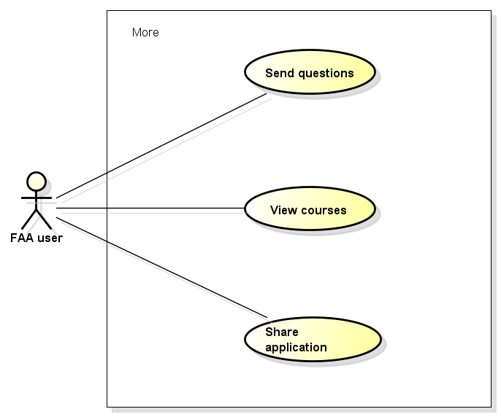

Figure -5: More use case

##### UC0013 - Send questions

|  |  |  |  |  |
| --- | --- | --- | --- | --- |
| **Use Case ID** | | UC0013 | **Version** | 1.1 |
| **Use Case Name** | | Send questions | | |
| **Created by:** | | AnhND | **Date Created:** | 24/09/2016 |
| **Primary Actor** | | FAA user | **Secondary Actor** |  |
| **Description:** | | This function allows user to send questions about injuries or send feedback about application | | |
| **Preconditions:** | | 1. Install First Aid application 2. User launches application 3. User taps on “Thêm” tab in menu bar | | |
| **Trigger:** | | User taps on “Ý kiến – Hỏi đáp” item | | |
| **Post conditions:** | | “Ý kiến – Hỏi đáp” screen is displayed to users fill information and send questions. | | |
| **Normal Flow** | | | | |
| **Step** | **Actor** | **Action** | | |
| 1 | FAA user | Taps on “Ý kiến – Hỏi đáp” item | | |
| 2 | FAA | Show “Ý kiến – Hỏi đáp” screen, include: - User name edit box - Email edit box - Title radio box - Content edit box | | |
| 3 | FAA  user | Fill information to name, mail, content edit box and choose radio box | | |
| 4 | FAA user | Tap “Gửi” button | | |
| 5 | FAA | Send question | | |
| **Alternative Flows:** | | | | |
| **AT1** | At step 2 in the main flows, if user taps on Back buttons. | | | |
| **Step** | **Actor** | **Action** | | |
| 2.1 | FAA | Redirects user to More screen | | |
| **Exceptions:** | | | | |
| **EC1** | At step 2 in the main flows, if required edit box are not entered | | | |
| **Step** | **Actor** | **Action** | | |
| 4.1 | FAA | Notify error message “Chưa nhập tên”, “Chưa nhập mail”, “Chưa nhập nội dung” | | |
| **EC2** | At step 2 in the main flows, if mail text box are entered with wrong type of data | | | |
| **Step** | **Actor** | **Action** | | |
| 4.1 | FAA | Notify error message “Sai định dạng email” | | |
| **Priority** | | High | | |
| **Frequency of Use:** | | High | | |
| **Business Rules:** | | B1, B2, B3 | | |
| **Other Information:** | | N/A | | |

Table 2- 19: Send question

##### UC0014 - View course

|  |  |  |  |  |
| --- | --- | --- | --- | --- |
| **Use Case ID** | | UC0014 | **Version** | 1.1 |
| **Use Case Name** | | View course | | |
| **Created by:** | | AnhND | **Date Created:** | 24/09/2016 |
| **Primary Actor** | | FAA user | **Secondary Actor** |  |
| **Description:** | | This function allows user to view first aid courses are organized by the 115 Hanoi center. | | |
| **Preconditions:** | | 1. Install First Aid application 2. User launches application 3. User taps on “Thêm” tab in menu bar | | |
| **Trigger:** | | User taps on “Khóa học sơ cấp cứu” item | | |
| **Post conditions:** | | The information about first aid courses are displayed in Courses screen. | | |
| **Normal Flow** | | | | |
| **Step** | **Actor** | **Action** | | |
| 1 | FAA user | Tap on “Khóa học sơ cấp cứu” item | | |
| 2 | FAA | Show the The information about first aid courses | | |
| **Alternative Flows:** | | | | |
| **AT1** | At step 2 in the main flows, if user taps on Back buttons. | | | |
| **Step** | **Actor** | **Action** | | |
| 2.1 | FAA | Redirects user to More screen | | |
| **Exceptions: N/A** | | | | |
| **Priority** | | High | | |
| **Frequency of Use:** | | High | | |
| **Business Rules:** | |  | | |
| **Other Information:** | | N/A | | |

Table 2- 19: View course

##### UC0015 - Share application

|  |  |  |  |  |
| --- | --- | --- | --- | --- |
| **Use Case ID** | | UC0015 | **Version** | 1.1 |
| **Use Case Name** | | Share application | | |
| **Created by:** | | AnhND | **Date Created:** | 24/09/2016 |
| **Primary Actor** | | FAA user | **Secondary Actor** |  |
| **Description:** | | This function allows user to share the application through third party applications. | | |
| **Preconditions:** | | 1. Install First Aid application 2. User launches application 3. User taps on “Thêm” tab in menu bar | | |
| **Trigger:** | | User taps on “Chia sẻ” item | | |
| **Post conditions:** | | The application is shared to third party applications. | | |
| **Normal Flow** | | | | |
| **Step** | **Actor** | **Action** | | |
| 1 | FAA user | Tap on “Chia sẻ” item | | |
| 2 | FAA | Show list of third party applications to share: - Facebook - Message - Zalo - … | | |
| 3 | FAA user | Tap on any third party application | | |
| 4 | FAA user | Tap on Post button | | |
| 5 | FAA | Share FAA to this third party application | | |
| **Alternative Flows: N/A** | | | | |
| **Exceptions: N/A** | | | | |
| **Priority** | | High | | |
| **Frequency of Use:** | | High | | |
| **Business Rules:** | |  | | |
| **Other Information:** | | N/A | | |

Table 2- 19: Share application

#### Setting Module

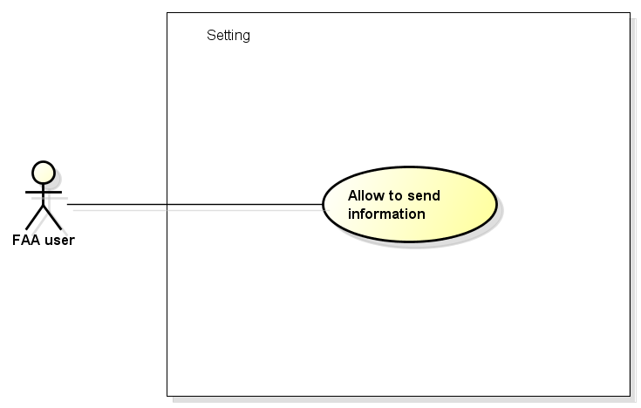

Figure -5: Setting use case

##### UC0016 - Allow to send information

|  |  |  |  |  |
| --- | --- | --- | --- | --- |
| **Use Case ID** | | UC0016 | **Version** | 1.1 |
| **Use Case Name** | | Allow to send information | | |
| **Created by:** | | AnhND | **Date Created:** | 24/09/2016 |
| **Primary Actor** | | FAA user | **Secondary Actor** |  |
| **Description:** | | This function allows user to choose that send or not their information include coordinates and phone number to 115 Dispatcher application. | | |
| **Preconditions:** | | 1. Install First Aid application 2. User launches application 3. User taps on “Cài đặt” tab in menu bar | | |
| **Trigger:** | | 1. “Đồng ý gửi” switch in “Cài đặt” tab is on 2. User enters their phone number in “Nhập số điện thoại” item and tap OK button | | |
| **Post conditions:** | | The user’s information include coordinates and phone number will be sent when user calls 115 | | |
| **Normal Flow** | | | | |
| **Step** | **Actor** | **Action** | | |
| 1 | FAA user | Tap on “Nhập số điện thoại” item | | |
| 2 | FAA | Show “Nhập số điện thoại” | | |
| 3 | FAA user | Enter phone number to | | |
| 4 | FAA user | Tap OK button | | |
| **Alternative Flows: N/A** | | | | |
| **Exceptions: N/A** | | | | |
| **Priority** | | High | | |
| **Frequency of Use:** | | High | | |
| **Business Rules:** | |  | | |
| **Other Information:** | | N/A | | |

Table 2- 19: Allow to send information

#### Information Module

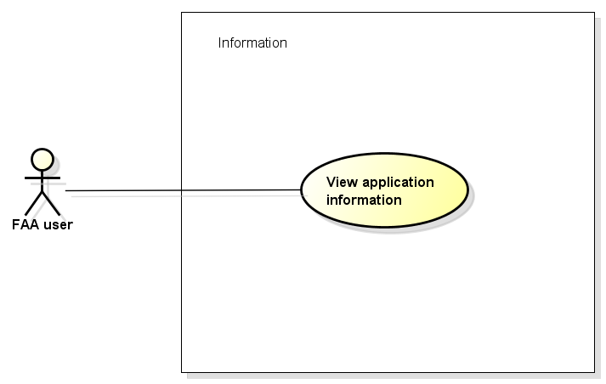

Figure -5: Information use case

##### UC0017 - View application information

|  |  |  |  |  |
| --- | --- | --- | --- | --- |
| **Use Case ID** | | UC0017 | **Version** | 1.1 |
| **Use Case Name** | | View application information | | |
| **Created by:** | | AnhND | **Date Created:** | 24/09/2016 |
| **Primary Actor** | | FAA user | **Secondary Actor** |  |
| **Description:** | | This function allows user to view the application information include terms of use, version of app, member of develop team. | | |
| **Preconditions:** | | 1. Install First Aid application 2. User launch application | | |
| **Trigger:** | | User taps on “Thông tin phần mềm” item in menu bar | | |
| **Post conditions:** | | All information about FAA will be displayed on information screen | | |
| **Normal Flow** | | | | |
| **Step** | **Actor** | **Action** | | |
| 1 | FAA user | Tap on “Thông tin phần mềm” item in menu bar | | |
| 2 | FAA | Show information about FAA include: - Terms of use - Version - Develop team | | |
| **Alternative Flows: N/A** | | | | |
| **Exceptions: N/A** | | | | |
| **Priority** | | High | | |
| **Frequency of Use:** | | High | | |
| **Business Rules:** | |  | | |
| **Other Information:** | | N/A | | |

Table 2- 19: View application information

### **Ambulance Application**

#### Common Module

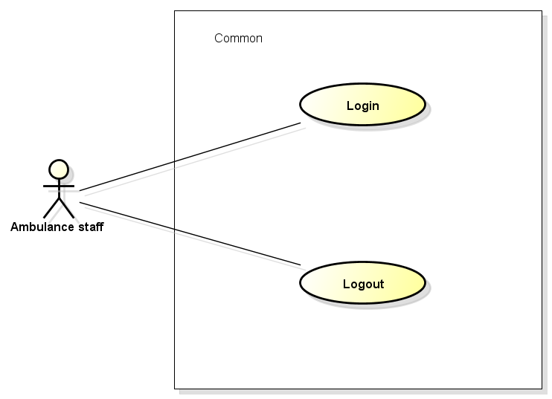

Figure -5: Common use case

##### UC0018 - Login

|  |  |  |  |  |
| --- | --- | --- | --- | --- |
| **Use Case ID** | | UC0018 | **Version** | 1.1 |
| **Use Case Name** | | Login | | |
| **Created by:** | | AnhND | **Date Created:** | 24/09/2016 |
| **Primary Actor** | | Ambulance staff | **Secondary Actor** |  |
| **Description:** | | This function allows ambulance staff login to Ambulance application to do tasks. | | |
| **Preconditions:** | | 1. Install Ambulance application 2. Ambulance staff launches application 3. Mobile device has Network 4. Ambulance staff was provide an account | | |
| **Trigger:** | | Ambulance staff enters username and password correctly in Login screen | | |
| **Post conditions:** | | 1. Ambulance staff login to application successful 2. Waiting screen is displayed | | |
| **Normal Flow** | | | | |
| **Step** | **Actor** | **Action** | | |
| 1 | Staff | Launch application | | |
| 2 | AMBA | Display Login screen with following fields: - User name - Password - Login button | | |
| 3 | Staff | Enter user name & password into User name & Password fields | | |
| 4 | Staff | Tap on Login button | | |
| 5 | AMBA | Validate the entered user name & password | | |
| 6 | AMBA | Display Waiting screen | | |
| **Alternative Flows: N/A** | | | | |
| **Exceptions:** | | | | |
| **EC1** | At step 3 in the main flows, if required edit box are not entered | | | |
| **Step** | **Actor** | **Action** | | |
| 3.1 | AMBA | Notify error message “Chưa nhập tên”, “Chưa nhập mật khẩu” | | |
| **Priority** | | High | | |
| **Frequency of Use:** | | High | | |
| **Business Rules:** | | B1, B2 | | |
| **Other Information:** | | N/A | | |

Table 2- 19: Login

##### UC0019 - Logout

|  |  |  |  |  |
| --- | --- | --- | --- | --- |
| **Use Case ID** | | UC0019 | **Version** | 1.1 |
| **Use Case Name** | | Logout | | |
| **Created by:** | | AnhND | **Date Created:** | 24/09/2016 |
| **Primary Actor** | | Ambulance staff | **Secondary Actor** |  |
| **Description:** | | This function allows ambulance staff logout to Ambulance application | | |
| **Preconditions:** | | 1. Install Ambulance application 2. Staff logged in to application | | |
| **Trigger:** | | User click Logout button in item menu | | |
| **Post conditions:** | | 1. Log staff out from application. 2. Redirect staff to login screen | | |
| **Normal Flow** | | | | |
| **Step** | **Actor** | **Action** | | |
| 1 | Staff | Tap on Logout button | | |
| 2 | AMBA | Redirect to login screen | | |
| **Alternative Flows: N/A** | | | | |
| **Exceptions: N/A** | | | | |
| **Priority** | | High | | |
| **Frequency of Use:** | | High | | |
| **Business Rules:** | |  | | |
| **Other Information:** | | N/A | | |

Table 2- 19: Logout

#### Task Module

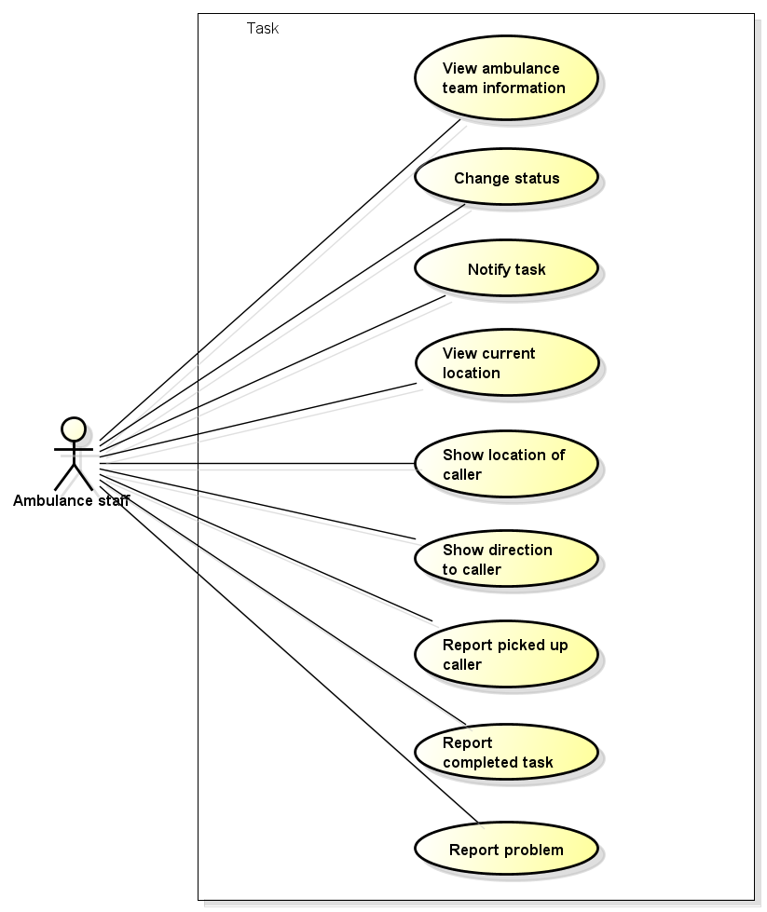

Figure -5: Task use case

##### UC0020 - View ambulance team information

|  |  |  |  |  |
| --- | --- | --- | --- | --- |
| **Use Case ID** | | UC0020 | **Version** | 1.1 |
| **Use Case Name** | | View ambulance team information | | |
| **Created by:** | | AnhND | **Date Created:** | 24/09/2016 |
| **Primary Actor** | | Ambulance staff | **Secondary Actor** |  |
| **Description:** | | This function allows ambulance staff to view the information of ambulance team | | |
| **Preconditions:** | | Install Ambulance application | | |
| **Trigger:** | | Staff logged in to application | | |
| **Post conditions:** | | The information of ambulance team is displayed in waiting screen | | |
| **Normal Flow** | | | | |
| **Step** | **Actor** | **Action** | | |
| 1 | Staff | Login to application | | |
| 2 | AMBA | Show ambulance team information | | |
| **Alternative Flows: N/A** | | | | |
| **Exceptions: N/A** | | | | |
| **Priority** | | High | | |
| **Frequency of Use:** | | High | | |
| **Business Rules:** | |  | | |
| **Other Information:** | | N/A | | |

Table 2- 19: View ambulance team information

##### UC0021 - Change status

|  |  |  |  |  |
| --- | --- | --- | --- | --- |
| **Use Case ID** | | UC0021 | **Version** | 1.1 |
| **Use Case Name** | | Change status | | |
| **Created by:** | | AnhND | **Date Created:** | 24/09/2016 |
| **Primary Actor** | | Ambulance staff | **Secondary Actor** |  |
| **Description:** | | This function allows ambulance staff to change status of ambulance | | |
| **Preconditions:** | | 1. Install Ambulance application 2. Staff logged in to application | | |
| **Trigger:** | | Staff taps on “Sẵn sàng” switch | | |
| **Post conditions:** | | Ready status is changed to Not ready status, waiting screen is dimmed and ambulance does not to receive task | | |
| **Normal Flow** | | | | |
| **Step** | **Actor** | **Action** | | |
| 1 | Staff | Tap on “Sẵn sàng” switch in waiting screen | | |
| 2 | AMBA | Ready status is changed to Not ready status | | |
| 3 | AMBA | Waiting screen is dimmed | | |
| 4 | AMBA | Does not to receive task | | |
| **Alternative Flows:** | | | | |
| **AT1** | At step 3 in the main flows, if user taps again on switch. | | | |
| **Step** | **Actor** | **Action** | | |
| 3.1 | AMBA | Not ready status is changed to Ready status | | |
| 3.2 | AMBA | Waiting screen lights up | | |
| 3.3 | AMBA | Ready to receive task | | |
| **Exceptions: N/A** | | | | |
| **Priority** | | High | | |
| **Frequency of Use:** | | High | | |
| **Business Rules:** | |  | | |
| **Other Information:** | | N/A | | |

Table 2- 19: Change status

##### UC0022 - Notify task

|  |  |  |  |  |
| --- | --- | --- | --- | --- |
| **Use Case ID** | | UC0022 | **Version** | 1.1 |
| **Use Case Name** | | Notify task | | |
| **Created by:** | | AnhND | **Date Created:** | 24/09/2016 |
| **Primary Actor** | | Ambulance staff | **Secondary Actor** |  |
| **Description:** | | This function allows ambulance staff to receive task | | |
| **Preconditions:** | | 1. Install Ambulance application 2. Staff logged in to application | | |
| **Trigger:** | | Ambulance staff receive task automatically when dispatcher click button dispatch | | |
| **Post conditions:** | | Notification about emergency is display on screen | | |
| **Normal Flow** | | | | |
| **Step** | **Actor** | **Action** | | |
| 1 | Staff | Login to application | | |
| 2 | Dispatcher | Dispatch ambulance | | |
| 3 | AMBA | Show dialog notify task: - “Từ chối/Chấp nhận” button | | |
| **Alternative Flows:** | | | | |
| **AT1** | At step 3 in the main flows, if staff taps on “Từ chối” button | | | |
| **Step** | **Actor** | **Action** | | |
| 3.1 | AMBA | Dialog notify task disappear | | |
| 3.2 | AMBA | Redirect to waiting screen and auto change status to Not ready | | |
| **AT2** | At step 3 in the main flows, if staff taps on “Chấp nhận” button | | | |
| **Step** | **Actor** | **Action** | | |
| 3.1 | AMBA | Redirect to Task screen | | |
| 3.2 | AMBA | Locate the caller’s location in map and show table “Thông tin” of caller | | |
| **Exceptions: N/A** | | | | |
| **Priority** | | High | | |
| **Frequency of Use:** | | High | | |
| **Business Rules:** | |  | | |
| **Other Information:** | | N/A | | |

Table 2- 19: Notify task

##### UC0023 - View current location

|  |  |  |  |  |
| --- | --- | --- | --- | --- |
| **Use Case ID** | | UC0023 | **Version** | 1.1 |
| **Use Case Name** | | View current location | | |
| **Created by:** | | AnhND | **Date Created:** | 24/09/2016 |
| **Primary Actor** | | Ambulance staff | **Secondary Actor** |  |
| **Description:** | | This function allows ambulance staff to locate the ambulance’s location in map | | |
| **Preconditions:** | | 1. Install Ambulance application 2. Staff accepts task | | |
| **Trigger:** | | Staff taps on Locate button in Task screen | | |
| **Post conditions:** | | The current ambulance’s location is displayed in map | | |
| **Normal Flow** | | | | |
| **Step** | **Actor** | **Action** | | |
| 1 | Staff | Tap on Locate button | | |
| 2 | AMBA | Display the current location of ambulance | | |
| **Alternative Flows:** | | | | |
| **AT1** | At step 2 in main flow, if staff scrolls in the Map | | | |
| **Step** | **Actor** | **Action** | | |
| 2.1 | AMBA | The Map is moved | | |
| 2.2 | Staff | Tap on Locate button | | |
| 2.3 | AMBA | Return to the current location of ambulance | | |
| **Exceptions: N/A** | | | | |
| **Priority** | | High | | |
| **Frequency of Use:** | | High | | |
| **Business Rules:** | |  | | |
| **Other Information:** | | N/A | | |

Table 2- 19: View current location

##### UC0024 - Show location of caller

|  |  |  |  |  |
| --- | --- | --- | --- | --- |
| **Use Case ID** | | UC0024 | **Version** | 1.1 |
| **Use Case Name** | | Show location of caller | | |
| **Created by:** | | AnhND | **Date Created:** | 24/09/2016 |
| **Primary Actor** | | Ambulance staff | **Secondary Actor** |  |
| **Description:** | | This function allows ambulance staff to show the location of caller | | |
| **Preconditions:** | | 1. Install Ambulance application 2. Staff accepts task 3. Staff scrolls in the Map | | |
| **Trigger:** | | Ambulance staff taps on Locate caller button | | |
| **Post conditions:** | | The current location of caller is located | | |
| **Normal Flow** | | | | |
| **Step** | **Actor** | **Action** | | |
| 1 | Staff | Scroll in the Map | | |
| 2 | Staff | Tap on Locate caller button in table “Thông tin” | | |
| 3 | AMBA | Return to the current location of caller | | |
| **Alternative Flows: N/A** | | | | |
| **Exceptions: N/A** | | | | |
| **Priority** | | High | | |
| **Frequency of Use:** | | High | | |
| **Business Rules:** | |  | | |
| **Other Information:** | | N/A | | |

Table 2- 19: Show location of caller

##### UC0025 - Show direction to caller

|  |  |  |  |  |
| --- | --- | --- | --- | --- |
| **Use Case ID** | | UC0025 | **Version** | 1.1 |
| **Use Case Name** | | Show direction to caller | | |
| **Created by:** | | AnhND | **Date Created:** | 24/09/2016 |
| **Primary Actor** | | Ambulance staff | **Secondary Actor** |  |
| **Description:** | | This function allows ambulance staff to see the direction to caller | | |
| **Preconditions:** | | 1. Install Ambulance application 2. Staff accepts task | | |
| **Trigger:** | | Ambulance staff taps on Direct button in table “Thông tin” | | |
| **Post conditions:** | | The direction from ambulance to caller is displayed | | |
| **Normal Flow** | | | | |
| **Step** | **Actor** | **Action** | | |
| 1 | Staff | Tap on Direct button in table “Thông tin” | | |
| 2 | AMBA | Show the direction to caller | | |
| **Alternative Flows: N/A** | | | | |
| **Exceptions: N/A** | | | | |
| **Priority** | | High | | |
| **Frequency of Use:** | | High | | |
| **Business Rules:** | |  | | |
| **Other Information:** | | N/A | | |

Table 2- 19: Show direction to caller

##### UC0026 - Report picked up caller

|  |  |  |  |  |
| --- | --- | --- | --- | --- |
| **Use Case ID** | | UC0026 | **Version** | 1.1 |
| **Use Case Name** | | Report picked up caller | | |
| **Created by:** | | AnhND | **Date Created:** | 24/09/2016 |
| **Primary Actor** | | Ambulance staff | **Secondary Actor** |  |
| **Description:** | | This function allows ambulance staff to report when picked up caller to dispatcher | | |
| **Preconditions:** | | 1. Install Ambulance application 2. Staff accepts task | | |
| **Trigger:** | | Ambulance staff taps on Picked up button in table “Thông tin” | | |
| **Post conditions:** | | Dialog confirm to picked up caller is displayed and send report to dispatcher | | |
| **Normal Flow** | | | | |
| **Step** | **Actor** | **Action** | | |
| 1 | Staff | Tap on Pickep up botton in table “Thông tin” | | |
| 2 | AMBA | Show dialog confirm to picked up caller: - “Hủy/Ok” button | | |
| 3 | Staff | Tap on Ok button | | |
| 4 | AMBA | Dialog confirm is disappeared and send report to dispatcher | | |
| **Alternative Flows:** | | | | |
| **AT1** | At step 2 in main flow, if staff taps on “Hủy” button | | | |
| **Step** | **Actor** | **Action** | | |
| 2.1 | AMBA | Dialog confirm is disappeared and not send report to dispatcher | | |
| **Exceptions: N/A** | | | | |
| **Priority** | | High | | |
| **Frequency of Use:** | | High | | |
| **Business Rules:** | |  | | |
| **Other Information:** | | N/A | | |

Table 2- 19: Report picked up caller

##### UC0027 - Report completed task

|  |  |  |  |  |
| --- | --- | --- | --- | --- |
| **Use Case ID** | | UC0027 | **Version** | 1.1 |
| **Use Case Name** | | Report completed task | | |
| **Created by:** | | AnhND | **Date Created:** | 24/09/2016 |
| **Primary Actor** | | Ambulance staff | **Secondary Actor** |  |
| **Description:** | | This function allows ambulance staff to report when completed task to dispatcher | | |
| **Preconditions:** | | 1. Install Ambulance application 2. Staff accepts task | | |
| **Trigger:** | | Ambulance staff taps on “Kết thúc” button | | |
| **Post conditions:** | | Dialog “Kết thúc nhiệm vụ” is displayed | | |
| **Normal Flow** | | | | |
| **Step** | **Actor** | **Action** | | |
| 1 | Staff | Tap on “Kết thúc” button | | |
| 2 | AMBA | Show dialog “Kết thúc nhiệm vụ”, content includes: - Checkbox: “Sẵn sàng làm nhiệm vụ tiếp theo”, default checked - No / Yes button | | |
| **Alternative Flows:** | | | | |
| **AT1** | At step 2 in main flow, if staff unchecks and taps on Yes button | | | |
| **Step** | **Actor** | **Action** | | |
| 2.1 | AMBA | Redirect to waiting screen, auto Not Ready status, waiting screen is dimmed | | |
| **AT2** | At step 2 in main flow, if staff checks and taps on Yes button | | | |
| **Step** | **Actor** | **Action** | | |
| 2.1 | AMBA | Redirect to waiting screen, auto Ready status, waiting screen lights up | | |
| **AT3** | At step 2 in main flow, if staff taps on No button | | | |
| **Step** | **Actor** | **Action** | | |
| 2.1 | AMBA | Dialog “Kết thúc nhiệm vụ” is disappeared, task is continued | | |
| **Exceptions: N/A** | | | | |
| **Priority** | | High | | |
| **Frequency of Use:** | | High | | |
| **Business Rules:** | |  | | |
| **Other Information:** | | N/A | | |

Table 2- 19: Report completed task

##### UC0028 - Report problem

|  |  |  |  |  |
| --- | --- | --- | --- | --- |
| **Use Case ID** | | UC0028 | **Version** | 1.1 |
| **Use Case Name** | | Report problem | | |
| **Created by:** | | AnhND | **Date Created:** | 24/09/2016 |
| **Primary Actor** | | Ambulance staff | **Secondary Actor** |  |
| **Description:** | | This function allows ambulance staff to report that they have problem to dispatcher | | |
| **Preconditions:** | | 1. Install Ambulance application 2. Staff accepts task | | |
| **Trigger:** | | Ambulance staff taps on “Báo sự cố” button | | |
| **Post conditions:** | | Make a call to the hotline of dispatcher | | |
| **Normal Flow** | | | | |
| **Step** | **Actor** | **Action** | | |
| 1 | Staff | Tap on “Báo sự cố” button | | |
| 2 | AMBA | Call to the hotline of dispatcher | | |
| **Alternative Flows: N/A** | | | | |
| **Exceptions: N/A** | | | | |
| **Priority** | | High | | |
| **Frequency of Use:** | | High | | |
| **Business Rules:** | |  | | |
| **Other Information:** | | N/A | | |

Table 2- 19: Report problem

#### Information Module

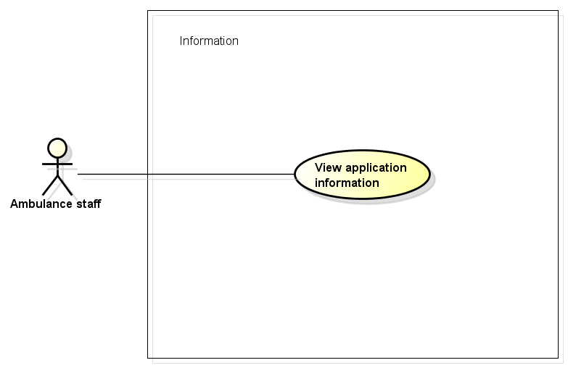

Figure -5: Information use case

##### UC0029 - View application information

|  |  |  |  |  |
| --- | --- | --- | --- | --- |
| **Use Case ID** | | UC0029 | **Version** | 1.1 |
| **Use Case Name** | | View application information | | |
| **Created by:** | | AnhND | **Date Created:** | 24/09/2016 |
| **Primary Actor** | | Ambulance staff | **Secondary Actor** |  |
| **Description:** | | This function allows ambulance staff to view the application information include terms of use, version of app, member of develop team. | | |
| **Preconditions:** | | 1. Install Ambulance application 2. Ambulance staff launches application | | |
| **Trigger:** | | Ambulance staff taps on “Thông tin phần mềm” item in item menu | | |
| **Post conditions:** | | All information about AMBA will be displayed on information screen | | |
| **Normal Flow** | | | | |
| **Step** | **Actor** | **Action** | | |
| 1 | Staff | Tap on “Thông tin phần mềm” item in item menu | | |
| 2 | AMBA | Show information about AMBA include: - Terms of use - Version - Develop team | | |
| **Alternative Flows: N/A** | | | | |
| **Exceptions: N/A** | | | | |
| **Priority** | | High | | |
| **Frequency of Use:** | | High | | |
| **Business Rules:** | |  | | |
| **Other Information:** | | N/A | | |

Table 2- 19: View application information

### **Dispatcher Application**

#### Common Module

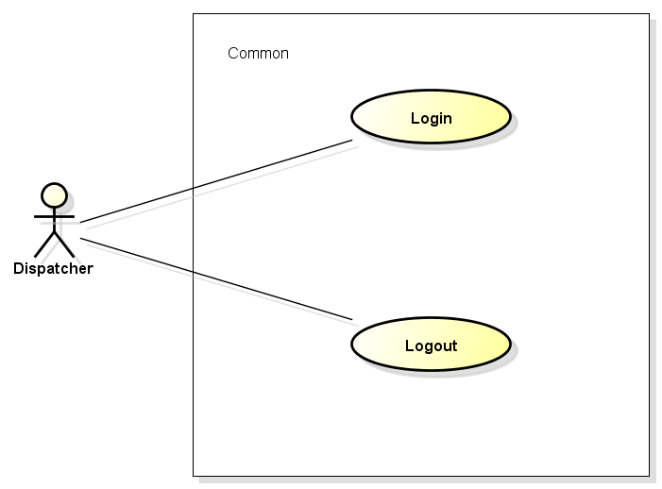

Figure -5: Common use case

##### UC0030 - Login

|  |  |  |  |  |
| --- | --- | --- | --- | --- |
| **Use Case ID** | | UC0030 | **Version** | 1.1 |
| **Use Case Name** | | Login | | |
| **Created by:** | | AnhND | **Date Created:** | 24/09/2016 |
| **Primary Actor** | | Dispatcher | **Secondary Actor** |  |
| **Description:** | | This function allows dispatcher login to Dispatcher web application to do tasks. | | |
| **Preconditions:** | | 1. Dispatcher web app is connected to the Internet 2. Dispatcher access Dispatcher web site 3. Dispatcher was provide an account | | |
| **Trigger:** | | Dispatcher enters username and password correctly in Login page | | |
| **Post conditions:** | | 1. Dispatcher login to application successful 2. Main screen is displayed | | |
| **Normal Flow** | | | | |
| **Step** | **Actor** | **Action** | | |
| 1 | Dispatcher | Access to Dispatcher web site | | |
| 2 | DPA | Display Login page with following fields: - User name - Password - Login button | | |
| 3 | Dispatcher | Enter user name & password into User name & Password fields | | |
| 4 | Dispatcher | Tap on Login button | | |
| 5 | DPA | Validate the entered user name & password | | |
| 6 | DPA | Display main screen, order from left to right: - “Điều phối” - Map - “Trường hợp khẩn cấp”, include: + “Đội cứu thương” + “Đang đợi” | | |
| **Alternative Flows: N/A** | | | | |
| **Exceptions: N/A** | | | | |
| **EC1** | At step 3 in the main flows, if required text box are not entered | | | |
| **Step** | **Actor** | **Action** | | |
| 3.1 | DPA | Notify error message “Chưa nhập tên” or “Chưa nhập mật khẩu” | | |
| **EC2** | At step 3 in the main flows, if user entered wrong User name or Password | | | |
| **Step** | **Actor** | **Action** | | | |
| 3.1 | DPA | Notify error message “Nhập sai tên” or “Nhập sai mật khẩu” | | |
| **Priority** | | High | | |
| **Frequency of Use:** | | High | | |
| **Business Rules:** | |  | | |
| **Other Information:** | | N/A | | |

Table 2- 19: Login

##### UC0031 - Logout

|  |  |  |  |  |
| --- | --- | --- | --- | --- |
| **Use Case ID** | | UC0031 | **Version** | 1.1 |
| **Use Case Name** | | Logout | | |
| **Created by:** | | AnhND | **Date Created:** | 24/09/2016 |
| **Primary Actor** | | Dispatcher | **Secondary Actor** |  |
| **Description:** | | This function allows dispatcher logout to web site | | |
| **Preconditions:** | | 1. Dispatcher web app is connected to the Internet 2. Dispatcher access Dispatcher web site 3. Dispatcher logged in to web site | | |
| **Trigger:** | | Dispatcher click Logout button in item menu | | |
| **Post conditions:** | | 1. Log dispatcher out from web site. 2. Redirect dispatcher to login page. | | |
| **Normal Flow** | | | | |
| **Step** | **Actor** | **Action** | | |
| 1 | Dispatcher | Tap on Logout button | | |
| 2 | DPA | Redirect to login page | | |
| **Alternative Flows: N/A** | | | | |
| **Exceptions: N/A** | | | | |
| **Priority** | | High | | |
| **Frequency of Use:** | | High | | |
| **Business Rules:** | |  | | |
| **Other Information:** | | N/A | | |

Table 2- 19: Logout

#### Dispatch Module

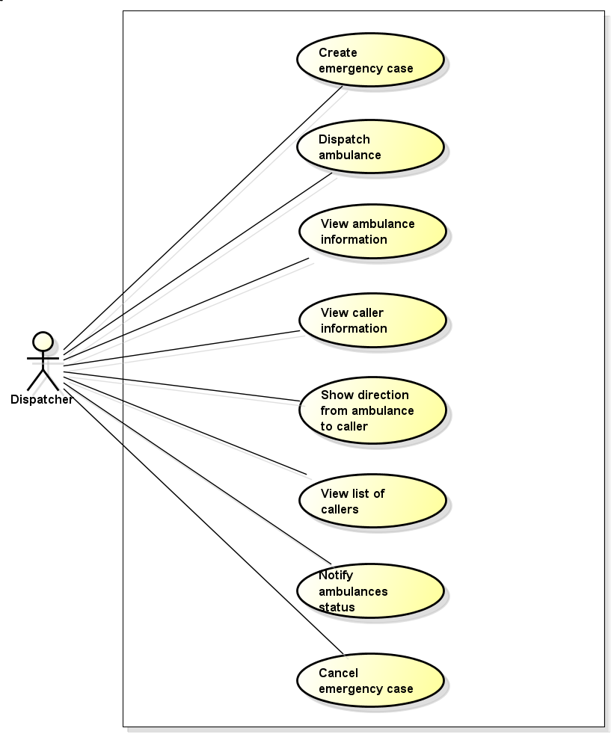

Figure -5: Dispatch use case

##### UC0032 - Create emergency case

|  |  |  |  |  |
| --- | --- | --- | --- | --- |
| **Use Case ID** | | UC0032 | **Version** | 1.1 |
| **Use Case Name** | | Create emergency case | | |
| **Created by:** | | AnhND | **Date Created:** | 24/09/2016 |
| **Primary Actor** | | Dispatcher | **Secondary Actor** |  |
| **Description:** | |  | | |
| **Preconditions:** | |  | | |
| **Trigger:** | |  | | |
| **Post conditions:** | |  | | |
| **Normal Flow** | | | | |
| **Step** | **Actor** | **Action** | | |
| 1 |  |  | | |
| 2 |  |  | | |
| 3 |  |  | | |
| **Alternative Flows:** | | | | |
| **AT1** |  | | | |
| **Step** | **Actor** | **Action** | | |
|  |  |  | | |
| **Exceptions: N/A** | | | | |
| **Priority** | | High | | |
| **Frequency of Use:** | | High | | |
| **Business Rules:** | |  | | |
| **Other Information:** | | N/A | | |

Table 2- 19: Create emergency case

##### UC0033 - Dispatch ambulance

|  |  |  |  |  |
| --- | --- | --- | --- | --- |
| **Use Case ID** | | UC0033 | **Version** | 1.1 |
| **Use Case Name** | | Dispatch ambulance | | |
| **Created by:** | | AnhND | **Date Created:** | 24/09/2016 |
| **Primary Actor** | | Dispatcher | **Secondary Actor** |  |
| **Description:** | |  | | |
| **Preconditions:** | |  | | |
| **Trigger:** | |  | | |
| **Post conditions:** | |  | | |
| **Normal Flow** | | | | |
| **Step** | **Actor** | **Action** | | |
| 1 |  |  | | |
| 2 |  |  | | |
| 3 |  |  | | |
| **Alternative Flows:** | | | | |
| **AT1** |  | | | |
| **Step** | **Actor** | **Action** | | |
|  |  |  | | |
| **Exceptions: N/A** | | | | |
| **Priority** | | High | | |
| **Frequency of Use:** | | High | | |
| **Business Rules:** | |  | | |
| **Other Information:** | | N/A | | |

Table 2- 19: Dispatch ambulance

##### UC0034 - View ambulance information

|  |  |  |  |  |
| --- | --- | --- | --- | --- |
| **Use Case ID** | | UC0034 | **Version** | 1.1 |
| **Use Case Name** | | View ambulance information | | |
| **Created by:** | | AnhND | **Date Created:** | 24/09/2016 |
| **Primary Actor** | | Dispatcher | **Secondary Actor** |  |
| **Description:** | |  | | |
| **Preconditions:** | |  | | |
| **Trigger:** | |  | | |
| **Post conditions:** | |  | | |
| **Normal Flow** | | | | |
| **Step** | **Actor** | **Action** | | |
| 1 |  |  | | |
| 2 |  |  | | |
| 3 |  |  | | |
| **Alternative Flows:** | | | | |
| **AT1** |  | | | |
| **Step** | **Actor** | **Action** | | |
|  |  |  | | |
| **Exceptions: N/A** | | | | |
| **Priority** | | High | | |
| **Frequency of Use:** | | High | | |
| **Business Rules:** | |  | | |
| **Other Information:** | | N/A | | |

Table 2- 19: View ambulance information

##### UC0035 - View caller information

|  |  |  |  |  |
| --- | --- | --- | --- | --- |
| **Use Case ID** | | UC0035 | **Version** | 1.1 |
| **Use Case Name** | | View caller information | | |
| **Created by:** | | AnhND | **Date Created:** | 24/09/2016 |
| **Primary Actor** | | Dispatcher | **Secondary Actor** |  |
| **Description:** | |  | | |
| **Preconditions:** | |  | | |
| **Trigger:** | |  | | |
| **Post conditions:** | |  | | |
| **Normal Flow** | | | | |
| **Step** | **Actor** | **Action** | | |
| 1 |  |  | | |
| 2 |  |  | | |
| 3 |  |  | | |
| **Alternative Flows:** | | | | |
| **AT1** |  | | | |
| **Step** | **Actor** | **Action** | | |
|  |  |  | | |
| **Exceptions: N/A** | | | | |
| **Priority** | | High | | |
| **Frequency of Use:** | | High | | |
| **Business Rules:** | |  | | |
| **Other Information:** | | N/A | | |

Table 2- 19: View caller information

##### UC0036 - Show direction from ambulance to caller

|  |  |  |  |  |
| --- | --- | --- | --- | --- |
| **Use Case ID** | | UC0036 | **Version** | 1.1 |
| **Use Case Name** | | Show direction from ambulance to caller | | |
| **Created by:** | | AnhND | **Date Created:** | 24/09/2016 |
| **Primary Actor** | | Dispatcher | **Secondary Actor** |  |
| **Description:** | |  | | |
| **Preconditions:** | |  | | |
| **Trigger:** | |  | | |
| **Post conditions:** | |  | | |
| **Normal Flow** | | | | |
| **Step** | **Actor** | **Action** | | |
| 1 |  |  | | |
| 2 |  |  | | |
| 3 |  |  | | |
| **Alternative Flows:** | | | | |
| **AT1** |  | | | |
| **Step** | **Actor** | **Action** | | |
|  |  |  | | |
| **Exceptions: N/A** | | | | |
| **Priority** | | High | | |
| **Frequency of Use:** | | High | | |
| **Business Rules:** | |  | | |
| **Other Information:** | | N/A | | |

Table 2- 19: Show direction from ambulance to caller

##### UC0037 - View list of waiting callers

|  |  |  |  |  |
| --- | --- | --- | --- | --- |
| **Use Case ID** | | UC0037 | **Version** | 1.1 |
| **Use Case Name** | | View list of waiting callers | | |
| **Created by:** | | AnhND | **Date Created:** | 24/09/2016 |
| **Primary Actor** | | Dispatcher | **Secondary Actor** |  |
| **Description:** | |  | | |
| **Preconditions:** | |  | | |
| **Trigger:** | |  | | |
| **Post conditions:** | |  | | |
| **Normal Flow** | | | | |
| **Step** | **Actor** | **Action** | | |
| 1 |  |  | | |
| 2 |  |  | | |
| 3 |  |  | | |
| **Alternative Flows:** | | | | |
| **AT1** |  | | | |
| **Step** | **Actor** | **Action** | | |
|  |  |  | | |
| **Exceptions: N/A** | | | | |
| **Priority** | | High | | |
| **Frequency of Use:** | | High | | |
| **Business Rules:** | |  | | |
| **Other Information:** | | N/A | | |

Table 2- 19: View list of waiting callers

##### UC0038 - Notify ambulances status

|  |  |  |  |  |
| --- | --- | --- | --- | --- |
| **Use Case ID** | | UC0038 | **Version** | 1.1 |
| **Use Case Name** | | Notify ambulances status | | |
| **Created by:** | | AnhND | **Date Created:** | 24/09/2016 |
| **Primary Actor** | | Dispatcher | **Secondary Actor** |  |
| **Description:** | |  | | |
| **Preconditions:** | |  | | |
| **Trigger:** | |  | | |
| **Post conditions:** | |  | | |
| **Normal Flow** | | | | |
| **Step** | **Actor** | **Action** | | |
| 1 |  |  | | |
| 2 |  |  | | |
| 3 |  |  | | |
| **Alternative Flows:** | | | | |
| **AT1** |  | | | |
| **Step** | **Actor** | **Action** | | |
|  |  |  | | |
| **Exceptions: N/A** | | | | |
| **Priority** | | High | | |
| **Frequency of Use:** | | High | | |
| **Business Rules:** | |  | | |
| **Other Information:** | | N/A | | |

Table 2- 19: Notify ambulances status

##### UC0039 - Cancel emergency case

|  |  |  |  |  |
| --- | --- | --- | --- | --- |
| **Use Case ID** | | UC0039 | **Version** | 1.1 |
| **Use Case Name** | |  | | |
| **Created by:** | | AnhND | **Date Created:** | 24/09/2016 |
| **Primary Actor** | | Dispatcher | **Secondary Actor** |  |
| **Description:** | |  | | |
| **Preconditions:** | |  | | |
| **Trigger:** | |  | | |
| **Post conditions:** | |  | | |
| **Normal Flow** | | | | |
| **Step** | **Actor** | **Action** | | |
| 1 |  |  | | |
| 2 |  |  | | |
| 3 |  |  | | |
| **Alternative Flows:** | | | | |
| **AT1** |  | | | |
| **Step** | **Actor** | **Action** | | |
|  |  |  | | |
| **Exceptions: N/A** | | | | |
| **Priority** | | High | | |
| **Frequency of Use:** | | High | | |
| **Business Rules:** | |  | | |
| **Other Information:** | | N/A | | |

Table 2- 19: Cancel emergency case

### **Admin/Expert Application**

#### Common Module

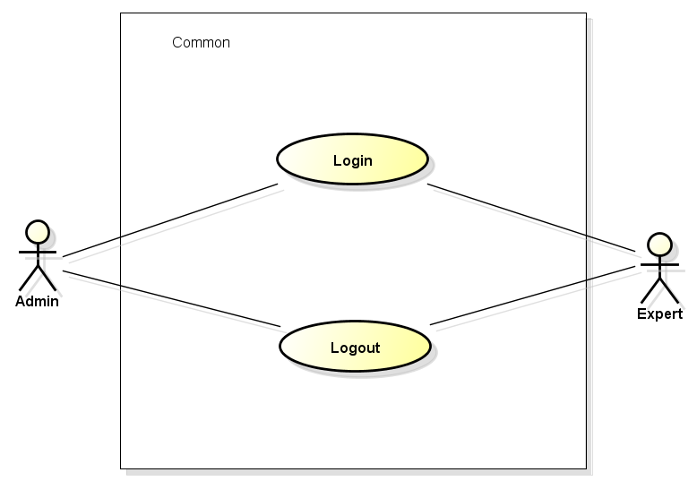

Figure -5: Common use case

##### UC0040 - Login

|  |  |  |  |  |
| --- | --- | --- | --- | --- |
| **Use Case ID** | | UC0040 | **Version** | 1.1 |
| **Use Case Name** | | Login | | |
| **Created by:** | | AnhND | **Date Created:** | 24/09/2016 |
| **Primary Actor** | | Admin/Expert | **Secondary Actor** |  |
| **Description:** | |  | | |
| **Preconditions:** | |  | | |
| **Trigger:** | |  | | |
| **Post conditions:** | |  | | |
| **Normal Flow** | | | | |
| **Step** | **Actor** | **Action** | | |
| 1 |  |  | | |
| 2 |  |  | | |
| 3 |  |  | | |
| **Alternative Flows:** | | | | |
| **AT1** |  | | | |
| **Step** | **Actor** | **Action** | | |
|  |  |  | | |
| **Exceptions: N/A** | | | | |
| **Priority** | | High | | |
| **Frequency of Use:** | | High | | |
| **Business Rules:** | |  | | |
| **Other Information:** | | N/A | | |

Table 2- 19: Login

##### UC0041 - Logout

|  |  |  |  |  |
| --- | --- | --- | --- | --- |
| **Use Case ID** | | UC0041 | **Version** | 1.1 |
| **Use Case Name** | | Logout | | |
| **Created by:** | | AnhND | **Date Created:** | 24/09/2016 |
| **Primary Actor** | | Admin/Expert | **Secondary Actor** |  |
| **Description:** | | This function allows | | |
| **Preconditions:** | |  | | |
| **Trigger:** | |  | | |
| **Post conditions:** | |  | | |
| **Normal Flow** | | | | |
| **Step** | **Actor** | **Action** | | |
| 1 |  |  | | |
| 2 |  |  | | |
| 3 |  |  | | |
| **Alternative Flows:** | | | | |
| **AT1** |  | | | |
| **Step** | **Actor** | **Action** | | |
|  |  |  | | |
| **Exceptions: N/A** | | | | |
| **Priority** | | High | | |
| **Frequency of Use:** | | High | | |
| **Business Rules:** | |  | | |
| **Other Information:** | | N/A | | |

Table 2- 19: Logout

#### Manage user's account Module

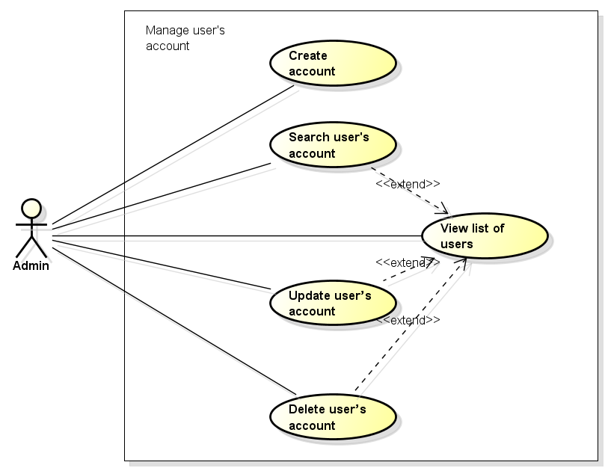

Figure -5: Manage user's account use case

##### UC0042 - Create account

|  |  |  |  |  |
| --- | --- | --- | --- | --- |
| **Use Case ID** | | UC0042 | **Version** | 1.1 |
| **Use Case Name** | | Create account | | |
| **Created by:** | | AnhND | **Date Created:** | 24/09/2016 |
| **Primary Actor** | | Admin | **Secondary Actor** |  |
| **Description:** | | This function allows | | |
| **Preconditions:** | |  | | |
| **Trigger:** | |  | | |
| **Post conditions:** | |  | | |
| **Normal Flow** | | | | |
| **Step** | **Actor** | **Action** | | |
| 1 |  |  | | |
| 2 |  |  | | |
| 3 |  |  | | |
| **Alternative Flows:** | | | | |
| **AT1** |  | | | |
| **Step** | **Actor** | **Action** | | |
|  |  |  | | |
| **Exceptions: N/A** | | | | |
| **Priority** | | High | | |
| **Frequency of Use:** | | High | | |
| **Business Rules:** | |  | | |
| **Other Information:** | | N/A | | |

Table 2- 19: Create account

##### UC0043 - View list of users

|  |  |  |  |  |
| --- | --- | --- | --- | --- |
| **Use Case ID** | | UC0043 | **Version** | 1.1 |
| **Use Case Name** | | View list of users | | |
| **Created by:** | | AnhND | **Date Created:** | 24/09/2016 |
| **Primary Actor** | | Admin | **Secondary Actor** |  |
| **Description:** | | This function allows | | |
| **Preconditions:** | |  | | |
| **Trigger:** | |  | | |
| **Post conditions:** | |  | | |
| **Normal Flow** | | | | |
| **Step** | **Actor** | **Action** | | |
| 1 |  |  | | |
| 2 |  |  | | |
| 3 |  |  | | |
| **Alternative Flows:** | | | | |
| **AT1** |  | | | |
| **Step** | **Actor** | **Action** | | |
|  |  |  | | |
| **Exceptions: N/A** | | | | |
| **Priority** | | High | | |
| **Frequency of Use:** | | High | | |
| **Business Rules:** | |  | | |
| **Other Information:** | | N/A | | |

Table 2- 19: View list of users

##### UC0044 - Search user's account

|  |  |  |  |  |
| --- | --- | --- | --- | --- |
| **Use Case ID** | | UC0044 | **Version** | 1.1 |
| **Use Case Name** | | Search user's account | | |
| **Created by:** | | AnhND | **Date Created:** | 24/09/2016 |
| **Primary Actor** | | Admin | **Secondary Actor** |  |
| **Description:** | | This function allows | | |
| **Preconditions:** | |  | | |
| **Trigger:** | |  | | |
| **Post conditions:** | |  | | |
| **Normal Flow** | | | | |
| **Step** | **Actor** | **Action** | | |
| 1 |  |  | | |
| 2 |  |  | | |
| 3 |  |  | | |
| **Alternative Flows:** | | | | |
| **AT1** |  | | | |
| **Step** | **Actor** | **Action** | | |
|  |  |  | | |
| **Exceptions: N/A** | | | | |
| **Priority** | | High | | |
| **Frequency of Use:** | | High | | |
| **Business Rules:** | |  | | |
| **Other Information:** | | N/A | | |

Table 2- 19: Search user's account

##### UC0045 - Update user’s account

|  |  |  |  |  |
| --- | --- | --- | --- | --- |
| **Use Case ID** | | UC0045 | **Version** | 1.1 |
| **Use Case Name** | | Update user's account | | |
| **Created by:** | | AnhND | **Date Created:** | 24/09/2016 |
| **Primary Actor** | | Admin | **Secondary Actor** |  |
| **Description:** | | This function allows | | |
| **Preconditions:** | |  | | |
| **Trigger:** | |  | | |
| **Post conditions:** | |  | | |
| **Normal Flow** | | | | |
| **Step** | **Actor** | **Action** | | |
| 1 |  |  | | |
| 2 |  |  | | |
| 3 |  |  | | |
| **Alternative Flows:** | | | | |
| **AT1** |  | | | |
| **Step** | **Actor** | **Action** | | |
|  |  |  | | |
| **Exceptions: N/A** | | | | |
| **Priority** | | High | | |
| **Frequency of Use:** | | High | | |
| **Business Rules:** | |  | | |
| **Other Information:** | | N/A | | |

Table 2- 19: Update user's account

##### UC0046 - Delete user’s account

|  |  |  |  |  |
| --- | --- | --- | --- | --- |
| **Use Case ID** | | UC0046 | **Version** | 1.1 |
| **Use Case Name** | | Delete user’s account | | |
| **Created by:** | | AnhND | **Date Created:** | 24/09/2016 |
| **Primary Actor** | | Admin | **Secondary Actor** |  |
| **Description:** | | This function allows | | |
| **Preconditions:** | |  | | |
| **Trigger:** | |  | | |
| **Post conditions:** | |  | | |
| **Normal Flow** | | | | |
| **Step** | **Actor** | **Action** | | |
| 1 |  |  | | |
| 2 |  |  | | |
| 3 |  |  | | |
| **Alternative Flows:** | | | | |
| **AT1** |  | | | |
| **Step** | **Actor** | **Action** | | |
|  |  |  | | |
| **Exceptions: N/A** | | | | |
| **Priority** | | High | | |
| **Frequency of Use:** | | High | | |
| **Business Rules:** | |  | | |
| **Other Information:** | | N/A | | |

Table 2- 19: Delete user’s account

#### Manage Q&A Module

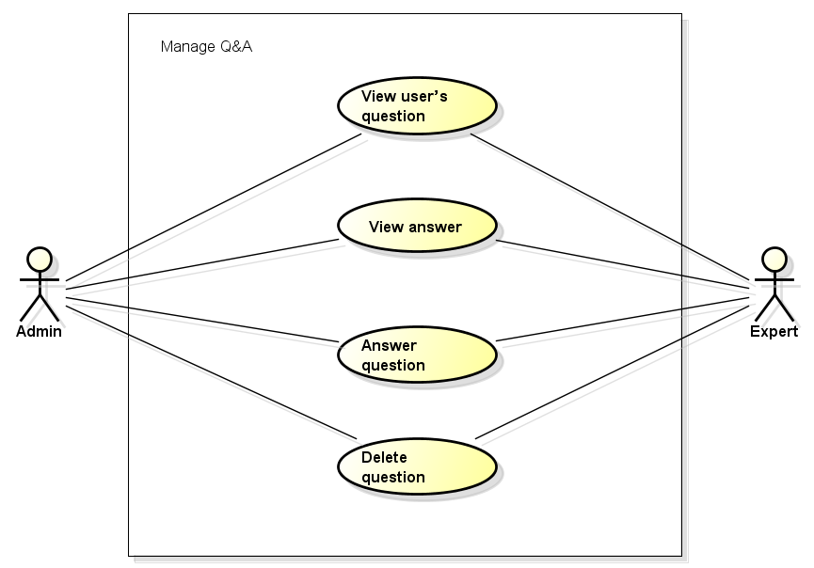

Figure -5: Manage Q&A use case

##### UC0047 - View user’s question

|  |  |  |  |  |
| --- | --- | --- | --- | --- |
| **Use Case ID** | | UC0047 | **Version** | 1.1 |
| **Use Case Name** | | View user’s question | | |
| **Created by:** | | AnhND | **Date Created:** | 24/09/2016 |
| **Primary Actor** | | Admin/Expert | **Secondary Actor** |  |
| **Description:** | | This function allows | | |
| **Preconditions:** | |  | | |
| **Trigger:** | |  | | |
| **Post conditions:** | |  | | |
| **Normal Flow** | | | | |
| **Step** | **Actor** | **Action** | | |
| 1 |  |  | | |
| 2 |  |  | | |
| 3 |  |  | | |
| **Alternative Flows:** | | | | |
| **AT1** |  | | | |
| **Step** | **Actor** | **Action** | | |
|  |  |  | | |
| **Exceptions: N/A** | | | | |
| **Priority** | | High | | |
| **Frequency of Use:** | | High | | |
| **Business Rules:** | |  | | |
| **Other Information:** | | N/A | | |

Table 2- 19: View user’s question

##### UC0048 - View answer

|  |  |  |  |  |
| --- | --- | --- | --- | --- |
| **Use Case ID** | | UC0048 | **Version** | 1.1 |
| **Use Case Name** | | View answer | | |
| **Created by:** | | AnhND | **Date Created:** | 24/09/2016 |
| **Primary Actor** | | Admin/Expert | **Secondary Actor** |  |
| **Description:** | | This function allows | | |
| **Preconditions:** | |  | | |
| **Trigger:** | |  | | |
| **Post conditions:** | |  | | |
| **Normal Flow** | | | | |
| **Step** | **Actor** | **Action** | | |
| 1 |  |  | | |
| 2 |  |  | | |
| 3 |  |  | | |
| **Alternative Flows:** | | | | |
| **AT1** |  | | | |
| **Step** | **Actor** | **Action** | | |
|  |  |  | | |
| **Exceptions: N/A** | | | | |
| **Priority** | | High | | |
| **Frequency of Use:** | | High | | |
| **Business Rules:** | |  | | |
| **Other Information:** | | N/A | | |

Table 2- 19: View answer

##### UC0049 - Answer question

|  |  |  |  |  |
| --- | --- | --- | --- | --- |
| **Use Case ID** | | UC0049 | **Version** | 1.1 |
| **Use Case Name** | | Answer question | | |
| **Created by:** | | AnhND | **Date Created:** | 24/09/2016 |
| **Primary Actor** | | Admin/Expert | **Secondary Actor** |  |
| **Description:** | | This function allows | | |
| **Preconditions:** | |  | | |
| **Trigger:** | |  | | |
| **Post conditions:** | |  | | |
| **Normal Flow** | | | | |
| **Step** | **Actor** | **Action** | | |
| 1 |  |  | | |
| 2 |  |  | | |
| 3 |  |  | | |
| **Alternative Flows:** | | | | |
| **AT1** |  | | | |
| **Step** | **Actor** | **Action** | | |
|  |  |  | | |
| **Exceptions: N/A** | | | | |
| **Priority** | | High | | |
| **Frequency of Use:** | | High | | |
| **Business Rules:** | |  | | |
| **Other Information:** | | N/A | | |

Table 2- 19: Answer question

##### UC0050 - Delete question

|  |  |  |  |  |
| --- | --- | --- | --- | --- |
| **Use Case ID** | | UC0050 | **Version** | 1.1 |
| **Use Case Name** | | Delete question | | |
| **Created by:** | | AnhND | **Date Created:** | 24/09/2016 |
| **Primary Actor** | | Admin/Expert | **Secondary Actor** |  |
| **Description:** | | This function allows | | |
| **Preconditions:** | |  | | |
| **Trigger:** | |  | | |
| **Post conditions:** | |  | | |
| **Normal Flow** | | | | |
| **Step** | **Actor** | **Action** | | |
| 1 |  |  | | |
| 2 |  |  | | |
| 3 |  |  | | |
| **Alternative Flows:** | | | | |
| **AT1** |  | | | |
| **Step** | **Actor** | **Action** | | |
|  |  |  | | |
| **Exceptions: N/A** | | | | |
| **Priority** | | High | | |
| **Frequency of Use:** | | High | | |
| **Business Rules:** | |  | | |
| **Other Information:** | | N/A | | |

Table 2- 19: Delete question

#### Manage injury Module

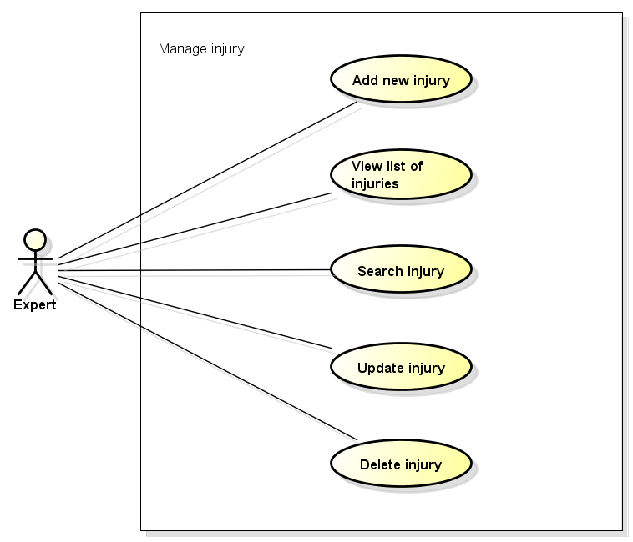

Figure -5: Manage injury use case

##### UC0051 - Add new injury

|  |  |  |  |  |
| --- | --- | --- | --- | --- |
| **Use Case ID** | | UC0051 | **Version** | 1.1 |
| **Use Case Name** | | Add new injury | | |
| **Created by:** | | AnhND | **Date Created:** | 24/09/2016 |
| **Primary Actor** | | Expert | **Secondary Actor** |  |
| **Description:** | | This function allows | | |
| **Preconditions:** | |  | | |
| **Trigger:** | |  | | |
| **Post conditions:** | |  | | |
| **Normal Flow** | | | | |
| **Step** | **Actor** | **Action** | | |
| 1 |  |  | | |
| 2 |  |  | | |
| 3 |  |  | | |
| **Alternative Flows:** | | | | |
| **AT1** |  | | | |
| **Step** | **Actor** | **Action** | | |
|  |  |  | | |
| **Exceptions: N/A** | | | | |
| **Priority** | | High | | |
| **Frequency of Use:** | | High | | |
| **Business Rules:** | |  | | |
| **Other Information:** | | N/A | | |

Table 2- 19: Add new injury

##### UC0052 - View list of injuries

|  |  |  |  |  |
| --- | --- | --- | --- | --- |
| **Use Case ID** | | UC0052 | **Version** | 1.1 |
| **Use Case Name** | | View list of injuries | | |
| **Created by:** | | AnhND | **Date Created:** | 24/09/2016 |
| **Primary Actor** | | Expert | **Secondary Actor** |  |
| **Description:** | | This function allows | | |
| **Preconditions:** | |  | | |
| **Trigger:** | |  | | |
| **Post conditions:** | |  | | |
| **Normal Flow** | | | | |
| **Step** | **Actor** | **Action** | | |
| 1 |  |  | | |
| 2 |  |  | | |
| 3 |  |  | | |
| **Alternative Flows:** | | | | |
| **AT1** |  | | | |
| **Step** | **Actor** | **Action** | | |
|  |  |  | | |
| **Exceptions: N/A** | | | | |
| **Priority** | | High | | |
| **Frequency of Use:** | | High | | |
| **Business Rules:** | |  | | |
| **Other Information:** | | N/A | | |

Table 2- 19: View list of injuries

##### UC0053 - Search injury

|  |  |  |  |  |
| --- | --- | --- | --- | --- |
| **Use Case ID** | | UC0053 | **Version** | 1.1 |
| **Use Case Name** | | Search injury | | |
| **Created by:** | | AnhND | **Date Created:** | 24/09/2016 |
| **Primary Actor** | | Expert | **Secondary Actor** |  |
| **Description:** | | This function allows | | |
| **Preconditions:** | |  | | |
| **Trigger:** | |  | | |
| **Post conditions:** | |  | | |
| **Normal Flow** | | | | |
| **Step** | **Actor** | **Action** | | |
| 1 |  |  | | |
| 2 |  |  | | |
| 3 |  |  | | |
| **Alternative Flows:** | | | | |
| **AT1** |  | | | |
| **Step** | **Actor** | **Action** | | |
|  |  |  | | |
| **Exceptions: N/A** | | | | |
| **Priority** | | High | | |
| **Frequency of Use:** | | High | | |
| **Business Rules:** | |  | | |
| **Other Information:** | | N/A | | |

Table 2- 19: Search injury

##### UC0054 - Update injury

|  |  |  |  |  |
| --- | --- | --- | --- | --- |
| **Use Case ID** | | UC0054 | **Version** | 1.1 |
| **Use Case Name** | | Update injury | | |
| **Created by:** | | AnhND | **Date Created:** | 24/09/2016 |
| **Primary Actor** | | Expert | **Secondary Actor** |  |
| **Description:** | | This function allows | | |
| **Preconditions:** | |  | | |
| **Trigger:** | |  | | |
| **Post conditions:** | |  | | |
| **Normal Flow** | | | | |
| **Step** | **Actor** | **Action** | | |
| 1 |  |  | | |
| 2 |  |  | | |
| 3 |  |  | | |
| **Alternative Flows:** | | | | |
| **AT1** |  | | | |
| **Step** | **Actor** | **Action** | | |
|  |  |  | | |
| **Exceptions: N/A** | | | | |
| **Priority** | | High | | |
| **Frequency of Use:** | | High | | |
| **Business Rules:** | |  | | |
| **Other Information:** | | N/A | | |

Table 2- 19: Update injury

##### UC0055 - Delete injury

|  |  |  |  |  |
| --- | --- | --- | --- | --- |
| **Use Case ID** | | UC0055 | **Version** | 1.1 |
| **Use Case Name** | | Delete injury | | |
| **Created by:** | | AnhND | **Date Created:** | 24/09/2016 |
| **Primary Actor** | | Expert | **Secondary Actor** |  |
| **Description:** | | This function allows | | |
| **Preconditions:** | |  | | |
| **Trigger:** | |  | | |
| **Post conditions:** | |  | | |
| **Normal Flow** | | | | |
| **Step** | **Actor** | **Action** | | |
| 1 |  |  | | |
| 2 |  |  | | |
| 3 |  |  | | |
| **Alternative Flows:** | | | | |
| **AT1** |  | | | |
| **Step** | **Actor** | **Action** | | |
|  |  |  | | |
| **Exceptions: N/A** | | | | |
| **Priority** | | High | | |
| **Frequency of Use:** | | High | | |
| **Business Rules:** | |  | | |
| **Other Information:** | | N/A | | |

Table 2- 19: Delete injury

# **NON-FUNCTIONAL SPECIFICATION**

## **Reliability**

* + Mean time between failures: The mean time between each failure is expected to be about 480 hours of using.
  + The maximum bugs per function are 2 bugs/a function when user uses software within 2 months. The average number of bugs in the software during system testing is about to be around 1 bugs/KLOC.
  + The database must be backed up daily and can be recovered if necessary.

## **Performance Requirements**

### **Availability**

The application must be available 95% of time. Users can access to it everywhere from their

Web browser with internet connection.

### **Response time**

In term of response time, waiting time of processing will be 2 to 5 seconds; time to process any functions will not exceed 7 seconds.

## **Maintainability**

* + **Coding standards and naming conventions:**

**-** Output of the project must include coding standards and naming conventions documentations. Implementation code must be easy to maintain.

- If some components are reused, the documentations of those components must also be included.

* + **Design:** The design of the system must be loosely coupled that chances on some module will not affect others.
  + **Logging:**

**-** All the errors should be logged, supporting for bug fixing and maintenance.

- All strange or sensitive situations should also be logged.

* + **Mean time to repair:** Immediately when Administrator finds out problem or website is attacked/ hacked by someone. Average 1 day.

## **Usability**

Usability Requirements support the following from the perspective of its primary users:

* + **Efficiency of use:** user can complete each function in less than 12 actions
  + **Intuitiveness:** User can understand approximately 90% help/ error messages

## **Security Requirements**

In order to avoid unwanted access by strangers, the security implemented in various ways:

* + **User authorize**: Each function must be distributed system access and manipulate the individual parts. To edit information, user must declare their username and password before the operation. Functions will be show after users login dependencies user’s role and permission of each user.
  + **Manage Data Layer**: Only Administrator can modify database system.

## **Hardware/Software Requirements**

* + **Hardware requirement:**

**- Server:** Web service 2013, IIS8

**- Client:** PC/Laptop (window 7, window 8)

* + **Software requirements:**

**-** Web browser (Chrome 40.0, Firefox 30.0) with internet connection.

**-** Android 5.0 or higher.